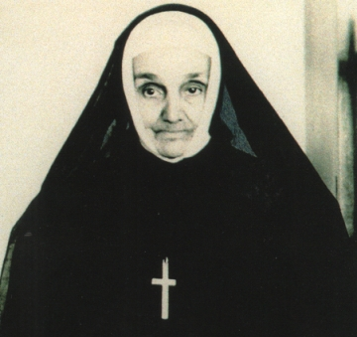
Blessed Marie Anne Blondin
This week we celebrate the feast of Blessed Marie Anne Blondin, an example of heroic obedience and humility to our prideful world. Mother Marie Anne was born as Esther Blondin in 1809 to deeply religious farmers in Quebec. She learned from her mother and father reliance upon Divine Providence, patience in suffering, and a love of the Eucharist. Her entire family was illiterate, and she grew up working on the farm. At age 22, Esther started working as a domestic in the Convent of the Sisters of the Congregation of Notre Dame. She registered in their school to learn to read and write. She then became a novice in the order, but left due to ill health. She became a teacher and realized that herself and many others never learned to read because the Church had a rule that male students could not be taught by female teachers, and female students could not be taught by male teachers. Due to this rule, there was a lack of teachers and most parishes couldn’t afford a school. At the age of 39, Esther presented to the Bishop a plan to establish a school for boys and girls in the country. The Bishop allowed her experiment, and she started the school along with a congregation of sisters to teach. She called the congregation The Sisters of St. Anne and became the Mother Superior. Mother Marie Anne’s congregation grew rapidly, and they moved to a new location. The new chaplain at the new location was Fr. Louis Marechal. He was not a fan of Mother Marie Anne and ruled her order as a dictator. The sisters weren’t allowed to go to other priests for confession, and he changed the school tuition without asking Mother. After a year of conflict, the Bishop asked Mother Marie Anne to resign at age 55. She respectfully obeyed and stepped down, allowing another sister to be Mother Superior. She was transferred to another convent of her order and given menial duties. She never complained and never fought back, but accepted it as Divine Providence. There she was also ridiculed and attacked by those influenced by Fr. Marechal. She was accused of being a poor administrator and recalled back to the Motherhouse. There she was sent to the laundry and ironing room to spend the rest of her life. Again, she obediently accepted the assignment and humbly obeyed the bishop who recommended she “take means that she will not be a nuisance to anyone.” Even though all these accusations were unfounded, Mother Marie Anne accepted them. One novice sked her why, as the Foundress, she was doing such menial work. She replied, “The deeper a tree sinks its roots into the soil, the greater are the chances of growing and producing fruit.” Mother Marie Anne knew her congregation was in God’s hands first, and her prayers and obedience did help her order grow immensely. She also knew her reward was not on this earth, but in heaven. She knew, “God will know well, in his Wisdom, how to discern the false from the true and to reward each one according to his deeds.” When Mother Marie Anne developed severe bronchitis at age 80, in characteristic humility, she called for Fr. Marechal to give her last rites and pardon her. She died in obscurity, so much so that she was not even listed in the directory of sisters when she was alive. No one knew about her life or that she even had founded the order until a generation after her death. A priest who knew her brought the details of her life to light and dispelled all the long-held prejudices against her. She was then beatified and honored as a blessed of heaven. May we follow Blessed Marie Anne’s example of humility and obedience in following the lead of our pastor and bishop, even when we have different preferences. Blessed Marie Anne Blondin, pray for us!

