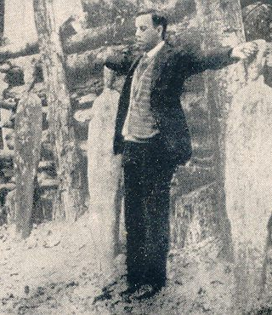
Blessed Miguel Pro
Blessed Jose Ramon Miguel Agustin Pro Juarez, or Blessed Miguel Pro, was born in 1891 in Mexico to a pious mining family. Two of his sisters later entered a convent. Miguel, always the playful jokester, also loved serving the poor miners with his father. He discerned a call to religious life, and joined the Jesuits. He was known in seminary as being witty, joyful, and charitable. Not too far into his seminary years, the government of Mexico became fiercely anti-clerical and anti-Catholic. President Calles began a widespread persecution of Catholicism like the country had never seen before. Catholics were hunted and executed. Many were hung and left on electrical poles running along railways, so the general public would see what happened to anyone practicing their faith. As the situation worsened, Miguel and the other Jesuits fled to the US and later Spain and Belgium to continue their seminary studies. Miguel also was a sickly young man at this time, always suffering from a stomach ailment. In Belgium, he was ordained a priest, and could not hold back his tears of heavenly joy. Shortly after, he voluntarily returned home to Mexico. The anti-Catholic persecutions were intense at this point, and Fr. Miguel was forced to minister to his flock covertly. Always the witty jokester, Fr. Miguel had a fun time fooling authorities while secretly celebrating the sacraments. He always had a disguise on hand, and went about his way staring death in the face. Sometimes he would dress up like a mechanic and hear confessions under the hood of a car. Other times he would be celebrating Mass when authorities barged in. He’d put on a police disguise and direct the other authorities on a wild goose chase to find “the priest.” One time he even walked into a police station to ask directions with no one thinking twice about it! Eventually, the authorities grew tired of being fooled and trumped up charges against Fr. Miguel and two of his brothers. They didn’t have a trial, but one of Fr. Miguel’s brothers was pardoned at the last minute. President Calles was excited he finally caught this priest, so he invited all the newspapers to come photograph his execution to frighten other Christians from further resistance. As he was being led out to the firing squad, one of the guards asked Father’s forgiveness. Fr. Miguel said he had already forgiven them. Then he knelt down and prayed for his executioners. He then stood up with his rosary in one hand and a crucifix in the other and raised his arms in cruciform. He cried out “May God have mercy on you! May God bless you! Lord, You know I am innocent! With all my heart I forgive my enemies!” Then as the firing squad was ordered to shoot, he shouted the cry of the Catholic resistance, “Viva Cristo Rey!” - “Long live Christ the King!” He was shot by the firing squad, but not killed, so a soldier shot him in the head at point-blank range. President Calles’ intent to dissuade resistance with the photographs only fueled them further. The government forbade anyone to go to his funeral, but 40,000 faithful showed up, blatantly disobeying the President. Other Catholics in resistance would also hold Miguel’s photograph as they stood in front of the firing squads facing their own deaths. As we celebrate the feast of Our Lord Jesus Christ, King of the Universe, let us adopt the cry of Blessed Miguel Pro “Viva Cristo Rey!” Let us be true soldiers of the King, and recognize that no matter what happens on this earth or in any government, that Christ rules supreme over all. Blessed Miguel Pro, pray for us!

