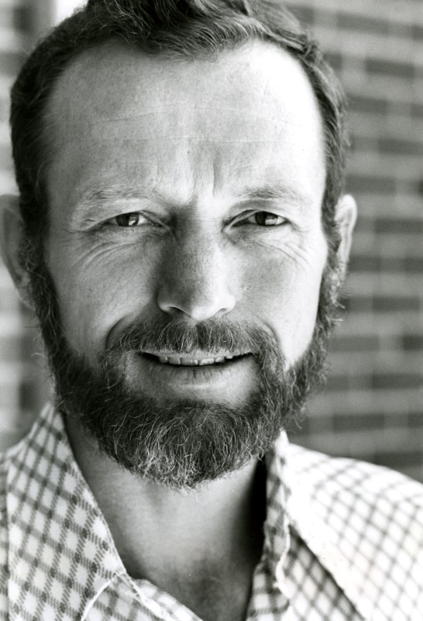
Blessed Stanley Rother and Loyalty
Stanley Francis Rother was born in Oklahoma in 1935. He grew up working hard on the family farm with two brothers and a sister who later entered the convent. Stanley felt a call to the priesthood and went to seminary where he struggled, especially in Latin. However, he persevered and was ordained a priest. He served at different parishes in Oklahoma until he applied to be a missionary to Guatemala in 1968 at age 33. There he learned Spanish and the unwritten indigenous language of Tz’utujil. Although he always struggled learning languages, he never gave up and mastered both languages. He eventually even translated the New Testament into Tz”utujil. He served the indigenous farming communities where he put his farm knowledge to work. He always was an advocate for education and supported a radio station that aired language and math lessons. Fr. Stanley also built a small hospital and served as liaison for the missions in Guatemala. His parishioners loved him and called him “Padre Apla’s” or “Father Francis,” since Stanley did not translate into Tz”utujil. When Fr. Stanley was 46 in 1981, the civil war in Guatemala became intense. Fr. Rother’s radio station was smashed and the directed murdered. His catechists and parishioners would disappear. Later their beaten and tortured bodies would be found. Fr. Stanley stayed in Guatemala in order to stay with his sheep. When his name was found on a death list, he returned to Oklahoma to save his life. However, he returned later that year to celebrate Easter with his flock. On July 28, 1981, three men broke into Fr. Stanley’s rectory and shot him twice in the head. His body was transferred and buried in Oklahoma, but his heart was taken out and buried under the Church in Guatemala. With the civil war still raging, no one was held responsible for his death. Pope Francis declared Fr. Stanley to be killed in hatred of the faith, thus proclaiming him a martyr. He is the first US born person to be declared a martyr. There is much to learn from this simple farm boy's life. Do we give ourselves to others, even those we’ve never met? Do we go the extra mile to evangelize others, or do we let setbacks and difficulties stop us? Do we live for ourselves in selfishness, or do we lay down our lives for others? Fr. Stanley was loyal to his parishioners until death. Are we loyal to our faith? Will we stand up as Christians when the time comes and look danger and ridicule in the face? Or will we cower in fear of not being accepted by society? Blessed Stanley Rother, pray for us!

