Fra Angelico
This week we celebrate the feast of Blessed John of Fiesole, O.P., more commonly known as Fra Angelico, or the angelic friar. He was born as Guido di Pietro in Italy around 1395. He entered the Dominicans taking the name John. It seems he and his older brother, also a Dominican friar, were trained in decorating manuscripts of the Bible. He also received training from many of the master artists around. Soon he was painting in Churches around and became very famous. Many started calling him Fra Giovanni Angelico, or Angelic Brother John, because of his holiness and the beauty of his paintings. He mostly painted all the different friaries he lived in, but he also was summoned to Rome by the Pope to paint in the Vatican. All the while he was painting, he also fulfilled his duties as a poor, simple, Dominican friar. At one point while painting in the Vatican, the Pope offered to make him the Archbishop of Florence, but Fra Angelico, always the humble friar, declined. He was also the prior of his friary for a few years. Fra Angelica trained other artists in the trade, and the famous Michelangelo is considered one of his artistic descendants. Fra Angelico died in 1455 around age 59. His epitaph reads, “When singing my praise, don’t liken my talents to those of Apelles (a famous Greek painter). Say, rather, that, in the name of Christ, I gave all I had to the poor. The deeds that count on Earth are not the ones that count in Heaven.” Pope St. John Paul II beatified Fra Angelico in 1982 due to his holiness, prayer, and art. He was devout, cared for the poor, practiced penances, and was always good humored. He only painted religious paintings, prayed intensely with each brush stroke, and felt divine inspiration for each work. He was known to say, “He who does Christ’s work must stay with Christ always.” It is said he always wept when painting a Crucifixion. Theologian Joseph Piper says that an artist has the most dangerous job in the world. Because an artist has such incredible talent and skill that the temptation is so strong to use his art for his own fame, glory, and gratification. But the artist was given his talents for the greater glory of God and must use them for God alone and no selfish reason. Fra Angelico recognized and lived that truth entirely, and that is why he is now Blessed John of Fiesole and the patron of Catholic artists. Fra Angelico, pray for us!
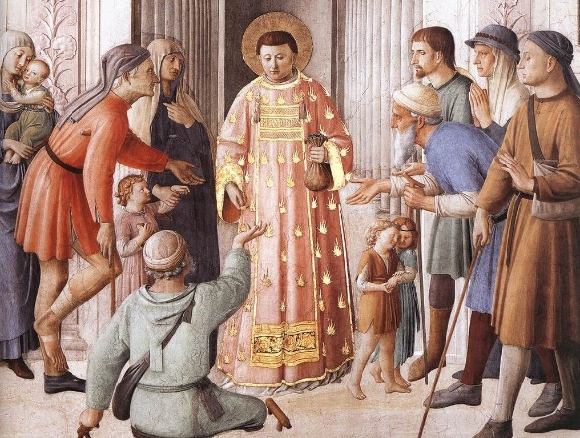
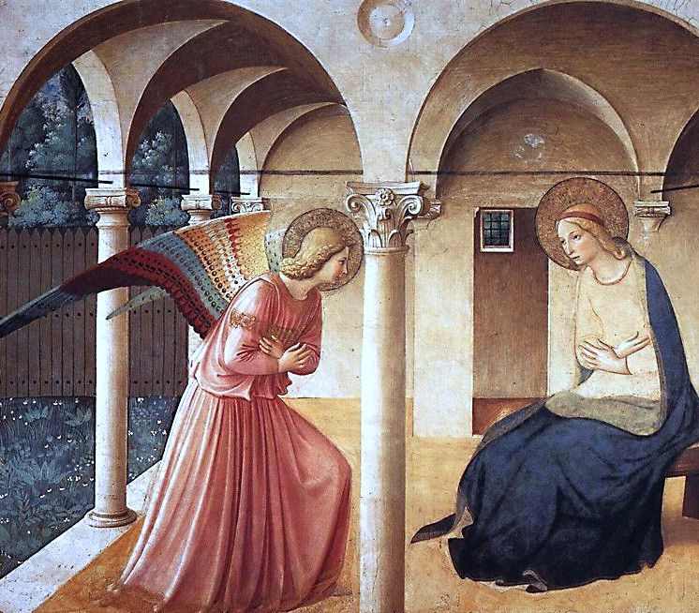
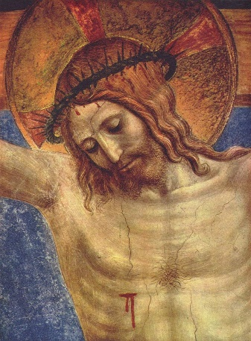
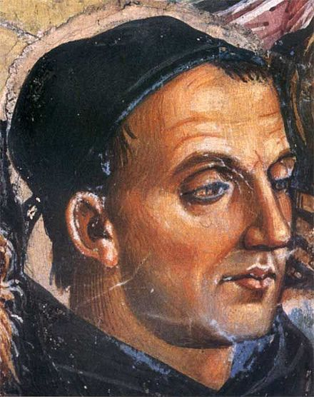
The Crucifixion. He was known to weep every time he painted the Crucifixion.
A painting of Fra Angelico by Luca Signorelli.
St. Lawrence distributing alms. Fra Angelico made many scenes of the life of St. Lawrence.
The Annunciation. This is probably his most famous piece.

