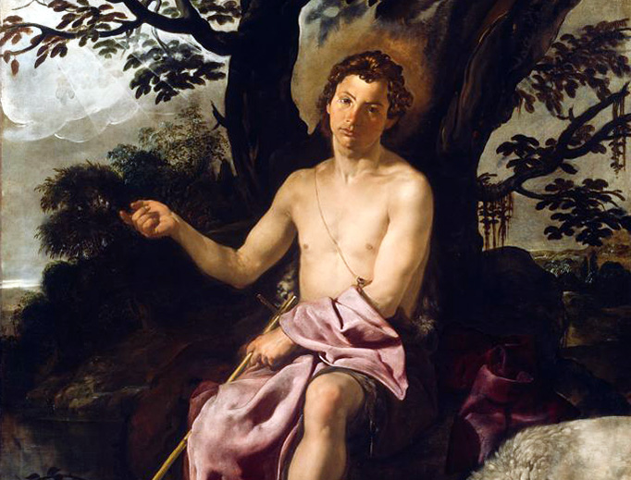

St. John the Baptist and the Power of Words
Many of us know the importance of St. John the Baptist’s life. But how much thought do we give his death? What a man is willing to die for speaks much of his character. John died for his words.
Herod Antipas was a Jewish ruler of the Roman occupied Galilee. Herod had left his first wife and married his brother Philip’s wife, Herodias. Both previous spouses were still alive. Given that Herod was the ruler and somewhat spiritual leader of the Jews, John spoke out against this act which was against the sanctity of marriage and Jewish law. John desired to inform Herod that his marriage was contrary to God and guide the Jewish people away from following their leader in his actions, which led away from God and His plan for our lives.
Herod and Herodias were upset that John called out their sinful behavior, so Herod had him arrested while Herodias brewed a deep hatred. Scripture states, “Herod feared John, knowing that he was a righteous and holy man, and kept him safe. When he heard him, he was much perplexed; and yet he heard him gladly” (Mark 6:20). This verse exposes the character and truth with which John spoke. He must have spoken Truth with great charity, compassion, and conviction. So much so, that Herod, who intensely disagreed with him, knew he was holy and was drawn to him and his words.
On the other hand, Herodias let resentment and hatred fester in her heart. When she got the chance, Herodias advised her daughter to ask for the head of John the Baptist on a platter. Herod was distressed, but carried out the request in fear of what his guests

might think. John was about 30 years old when he died for his witness to the Truth. Tradition has it, and many artists have depicted it, that Herodias kept John’s head and would occasionally pull out and stab his tongue repeatedly because of the hatred she bore for the words he spoke.
As we celebrate St. John the Baptist’s birth this week, let us reflect on the words we speak. Do we speak Truth in charity for the glory of God? Or do we use our words for gossip, slander, and our own glorification? Can someone tell we are Christians by our words? Or do we speak in a way no different from this world? Scripture tells us “on the day of judgement people will render an account for every careless word they speak” (Matt 12:36). Let us examine the words we speak, so everyone will know we are Christians by the love and truth in our words.

