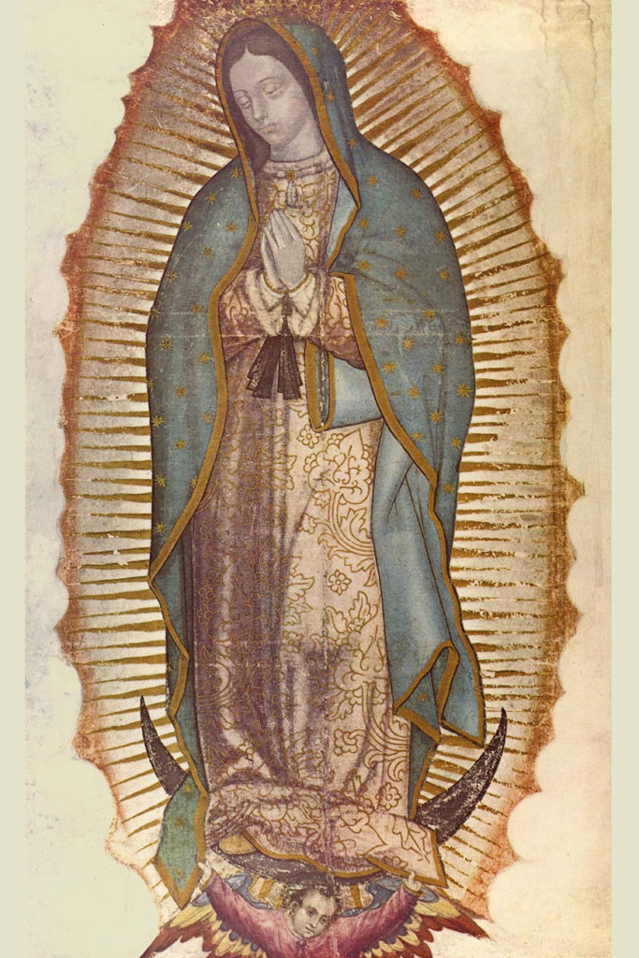
Our Lady Guadalupe
I’m sure we’ve all heard of Our Lady of Guadalupe, but do we know the significance of her? If we go back to Mexico in the 1500s, we can understand more. Spaniards discovered Mexico in the early 1500s, but the local natives killed a bunch of them upon arrival, so they retreated and came back with stronger forces to take over some territory. Different native tribes took different sides in the battles between the Spanish and the Aztecs, but the Spanish eventually took over and ended the Aztec empire. However, the Aztec people and the culture were still alive and harbored a grudge against the Spanish for obvious reasons. Many Spaniards also looked down upon the natives. So, when the Spanish Franciscan missionaries came to Mexico to bring the light of Christ, many natives hated them because they were Spanish and tensions were high. St. Juan Diego was a native, but he also accepted Christianity and was a rare native baptized Catholic. This put him right in the middle of the racism, yet he knew his culture and Catholicism could be reconciled. This occurred when Mary appeared to him in a few visions. He was a poor nobody, but Mary chose him. And no one believed him until he went and showed the Bishop roses Mary had given him in midwinter, and she appeared upon his tilma, or cloak. After this miracle, over 1 million natives were baptized and came to the faith. That is why we think of Mexico as a mostly Catholic culture. And this was largely because Mary appeared as a native to a native. The natives realized Mary was for them and their culture too. Mary’s appearance also bears significant details. First, she is standing on the moon, showing dominance over the main Aztec moon god. Second, she is a young native girl and the black band around her waist indicates she is pregnant. The constellation of stars on her mantle is the exact same as the day she appeared to Juan Diego. Scientists have also researched the tilma over and over and concluded that she is not painted or stamped upon the tilma from any substance. There are no brush strokes or any indication of how the image was made, but the image seems to be actually laying on top of the tilma and not imprinted on it. Furthermore, Mary’s eyes, which are partially closed, reflect the Bishop as he was standing there at the moment Juan Diego showed his tilma to him. Mary’s eyes will also reflect whatever she sees before her, just like normal human eyes. Finally, you can take a stethoscope and hear both the heartbeat of Mary and the heartbeat of Jesus inside her womb on the image. The crazy thing is Our Lady of Guadalupe isn’t just an image of Mary or an apparition that occurred 500 years ago. Mary is still there, constantly appearing here, and you can go see her in Mexico City! It is like an apparition that has lasted for 500 years. When you go see Our Lady of Guadalupe, many may just think, oh this is a picture of Mary. But if you really take the time to look closely, you realize this is not a picture of Mary, but it is Mary the Mother of God standing before me with Jesus in her womb. What a fantastic experience! May we consecrate ourselves to Jesus through Mary and let her lead us closer to heaven and her son! Our Lady of Guadalupe, pray for us!

