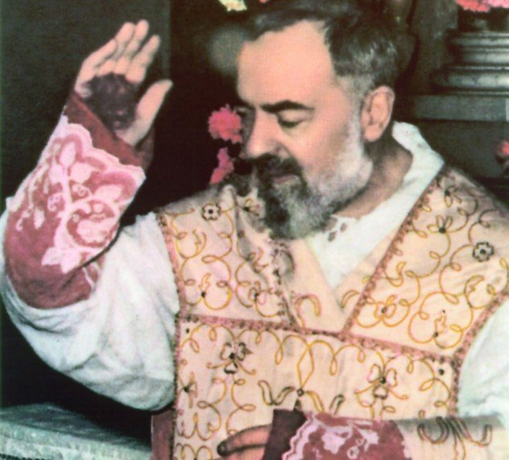
St. Padre Pio
St. Padre Pio was born Francesco Forgione to peasant farmers in Benevento, Italy. This is the same province where St. Januarius was from. Francesco’s family was uneducated, but pious. They attended Mass every day, prayed the Rosary every night, and fasted from meat three times a week in honor of Our Lady of Mount Carmel. Francesco early on experienced heavenly visions and wanted to join the Capuchin Franciscan Friars. However, to join the Capuchins, Francesco had to be better educated. So, his father went to find work in the U.S. in order to pay for private tutoring so Francesco could become a Friar. He eventually joined at age 15 and took the name Pius, or Pio in Italian. He struggled with frail health his whole life, but persevered. He also experienced many supernatural gifts. He had the gifts of healing, bilocation, levitation, prophecy, miracles, extraordinary abstinence from sleep and nourishment, the ability to read hearts, the gift of tongues, the gift of conversions, pleasant smelling wounds, and the stigmata. Demons also attacked and harassed him. The Church at first was skeptical of his gifts and restricted his ministry. However, after investigations he was free to return fully to his ministry. He used his spiritual gifts in ceaseless service to his flock. Pope Paul VI credited Pio’s greatness to him simply being a good priest. He said the Mass humbly, heard confessions from dawn to dusk, and was one who bore the wounds of our Lord. He was a man of prayer and suffering. At his father’s death, Padre Pio really desired to heal him from his illness, but he never used his healing gifts for his own desires. Another story tells of Padre Pio bilocating during WWI and appearing to a pilot flying in the sky to prevent him from dropping a bomb on a civilian town while at the same time being in his monastery as usual. Padre Pio was most famous for his stigmata, or the wounds of Christ. He had the stigmata for 50 years. It was constantly bleeding and painful. Padre Pio offered his suffering for all of mankind. His stigmata was studied time after time by multiple doctors, Church officials, and scientists, but no one had a natural explanation. Many miracles continue to be attributed to Padre Pio, and his body was found partially preserved 40 years after his death. While Padre Pio’s story is fascinating, it started simply with his family. His family prayed and fasted together. His father sacrificed to encourage his son to enter the Capuchin order. He persevered through struggles. Many people had many opposing opinions of him. Yet, he didn’t let this bother him and lived his life as God desired. He suffered, but did not ask for pity, but offered up his suffering. Finally, he died, looking forward to his birth into heaven. Let us all live by Padre Pio’s example, living our simple lives in great virtue. He also gave us 5 rules to grow in holiness: weekly confession, daily Communion, spiritual reading, meditation, and examination of conscience. Let us follow his advice, “Pray, hope, and do not worry!” St. Padre Pio, pray for us!

