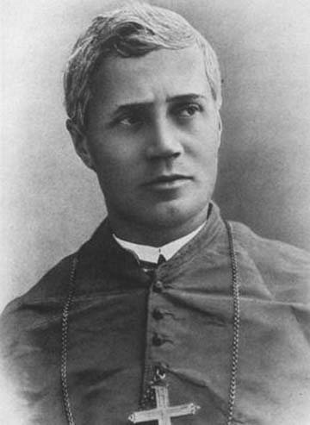
Pope St. Pius X
I recently heard a story of a young girl and her baby brother. When she was left alone with her baby brother, she went up to him and said, “can you remind me what God sounds like; I’m beginning to forget.” Children have an innate realization of the spiritual. They are not yet numb to the unseen world as we have become through years of hardships and strife this world has laid upon us. They more recently came from God than adults, so as this young girl demonstrated, they know what He sounds like. We must always remember to cultivate this spiritual life in children that many times we inadvertently hinder. Many vocations are realized in childhood, but are dispelled over the years as the spiritual life dies. Pope St. Pius X was one person who recognized the potential of children and fought for their spiritual life. He was even known as the children’s pope. Born as Giuseppe Sarto, he himself felt an early call and entered seminary at 15. He excelled and was ordained a priest at the young age of 23. When first ordained, he directed his energy toward fostering vocations and preparing young priests. He was very devoted to the Blessed Virgin, and lived in the spirit of poverty. He was also a philosopher and theologian, fighting vehemently against the attacks against the Church and her teachings. This mostly included modernism, the heresy that the Church and her teachings must keep up with the times and fit into modern thought and change doctrines to be in line with modern social opinions. This heresy has been around for hundreds of years all over the world and continues mostly unnoticed today. Due to his intelligence and piety, Giuseppe quickly became a bishop then cardinal. He was eventually elected pope, taking the name Pius X. While pope, he made many changes. It was in his papacy that he fought for the children most prominently. He had the Catechism translated into the common languages, and had catechesis taught in the common language so it was accessible to children. He also lowered the age of 1st Holy Communion to 7 and encouraged frequent, even daily, reception of Holy Communion to all the faithful in a state of grace. He also accomplished many other reforms in his papacy. Before he died he was even working miracles. One miracle happened as Pope Pius X was holding a paralyzed boy. The boy started wriggling free and ran around the room to everyone’s astonishment. We have much to learn from this holy pope. May we always support and foster the spiritual life and vocations of children. May we never lose the wonder and joy of a child’s heart. And may we always listen for and know the voice of God Our Father. St. Pope Pius X, pray for us!

