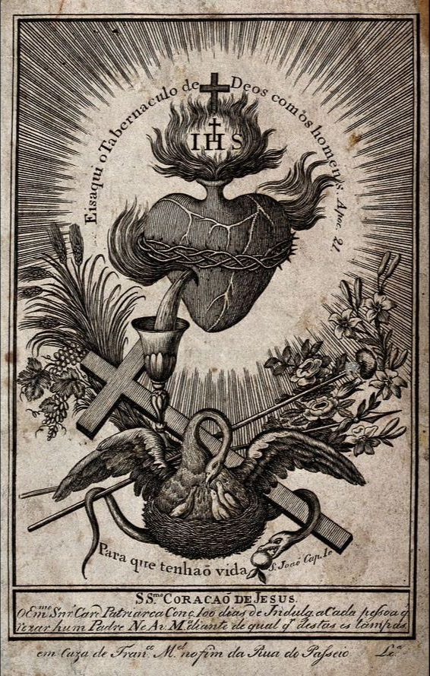

The Sacred Heart of Jesus

The devotion to the Most Sacred Heart of Jesus began when His Heart was pierced on the cross. However, it was widely popularized by St. Margaret Mary Alacoque in the 1600s after Jesus appeared to her in many visions, stressing his burning love for us. The Sacred Heart was most recently re-popularized by St. Faustina Kowalska in the 1900s. St. Faustina recorded her visions of Jesus in her diary, focusing on the mercy He desires to pour out to us. Both visionaries stressed Jesus’s heart burning for love of us. If only we would receive His Mercy and return our love. Let us remember that His Most Sacred human heart started beating for us when He took on flesh. It was interrupted for two days as he died and lay in the tomb. After the resurrection, it started again. Now the Most Sacred Heart of Jesus beats and will continue to beat for us for all eternity!
This depiction of the Sacred Heart is very detailed and exposes many elements of Jesus’ love for us. The words, “Here is the tabernacle of God become man” surround the heart, reminding us that this heart resides in all the tabernacles on earth, yet is the heart of God. The heart is surrounded by the crown of thorns with a cross above it. IHS is above the heart, reminding us that this Most Sacred Heart is also in the Eucharist we receive and consume. Fire is exploding from the heart in all directions showing that Jesus’ love and desire for us burns so passionately that it cannot be contained. Finally, pouring out from the pierced side into the chalice is the Blood and Water of the Son of God, who poured out all His blood to redeem us from our sins. On the left are wheat and grapes that are transubstantiated into the Body and Blood of Jesus at Mass. On the right are lilies of purity and roses of love. The cross and nails are present to remind us of Jesus passion and death for our salvation. The serpent with the apple reminds us of the fall of Adam and Eve, our inherited fallen nature, and all our personal sins that require a savior. Finally, the pelican rests on the bottom. The pelican has long been a symbol of Christ because it was said that if the need arose, a mother pelican would pierce her chest to nourish her young her own blood and sacrifice her own life to save them. The words “So that we may have life” grace the pelican’s nest, calling us to recognize this was all done for our salvation. Let us receive His mercy and return His love! Sweet Heart of Jesus, be my love!

