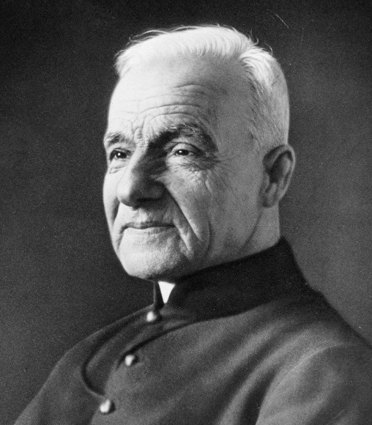
St. André Bessette & St. Joseph
We’ve had a lot of celebrations concentrating on Mary and Jesus, but St. Joseph flies mostly under the radar, but was a huge part of Christmas as well! St. André Bessette was one man who knew this well, probably because he too was a simple, humble man. Brother André, born as Alfred Bessette, grew up poor and frail in Canada in a large family. His parents died young, so Alfred had a hard childhood, yet he remained very pious. His pastor recognized the devotion and generosity of Alfred and recommended him to join the Congregation of the Holy Cross, the same order that founded The University of Notre Dame. Alfred was initially rejected due to his poor health, but his pastor convinced the order to take him saying, “I am sending you a saint.” Alfred took the name Brother André and became the door porter, a humble position he held for his time at the monastery. He never became a priest and never “moved up” in the world of the monastery, but he was happy with the humble life God had led him to, much like St. Joseph. Brother André had a deep devotion to St. Joseph, and cured many people through his intercession. He realized St. Joseph was very close to Jesus and could bring us closer to Jesus too! St. Joseph is the only man who God called father. Being the father of Jesus was a huge responsibility and gift, and the humble St. Joseph was the perfect man for the job. The saints give us legends and traditions of St. Joseph that expose more of his character. Many believe St. Joseph was consecrated as a virgin to God. When God was calling him to marry Mary, he knew his job would be to protect her virginity. When he realized Mary was pregnant, St. Joseph didn’t suspect her of cheating, but since he knew the sanctity of Mary, he recognized something extraordinarily holy and sacred was going on, and he did not feel worthy to take part. However, St. Joseph, always in accord with God’s will, listened to the angel and was obedient, taking Mary into his home. St. Joseph also was the one who named Jesus, since the angel instructed him, and that was the responsibility of the father. Jesus and St. Joseph also had a very special bond being that the father was the spiritual leader and only men could take part in some spiritual rituals. Jesus is both God and man, so St. Joseph also taught Jesus human things, like how to pray prayers aloud, how to be a carpenter, and how to show his love and affection to Mary. St. Joseph, being the breadwinner, fed Jesus, who would eventually feed all of humanity with his own flesh in the Eucharist. God would only choose the best father for his son, so St. Joseph was the best, most loving, protective, holy father ever. How much St. Joseph can also do for us, if we but ask him! Brother André knew all these things and built a deep friendship with St. Joseph. So many people were being cured by Brother André asking St. Joseph’s intercession that crowds of sick people would follow him. His religious brothers became nervous that diseases would spread in the monastery and pushed him to stop receiving sick people, but he didn’t stop and no diseases ever spread. Brother André received credit for the healings, but always said, “it is not me, it is St. Joseph!” Brother André finally built a chapel in honor of St. Joseph and became the caretaker of it for the rest of his simple life. He died in 1937 at the age of 91, and was canonized in 2010. May these two simple, humble, obedient, and holy men be a model for us! St. Joseph and St. André Bessette, pray for us!

