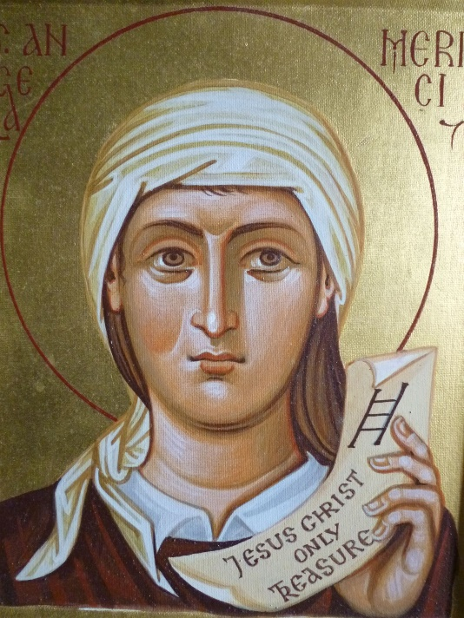
St. Angela Merici & families
This week we celebrate the feast of St. Angela Merici, the founder of the Ursulines. Our very own Sr. Mary Celine Weidenbenner is an Ursuline. Angela was born in 1474 in Lombardy, Italy. Orphaned at a fairly young age, she moved to live with relatives. Her older sister died suddenly without last rights leaving Angela grieving deeply and concerned over her sister’s eternal salvation. However, she prayed and had a vision of her sister in the company of the saints in heaven. After this experience, Angela decided to devote herself to God and became a Third Order Franciscan. As a laywoman still, her good looks (apparently mostly her beautiful hair) and charm started drawing the attention of many eligible suitors, but she had already pledged her virginity to God, so she dyed her hair with soot to deter the attention. Around this time as well, Angela became aware of young women around her who had no education and no hope. She was upset at the parents who had not educated them in religion or in life skills, so she opened her home and began to teach them herself to prepare them to be good holy wives and mothers. She mostly taught them the Catholic faith, how to pray, and how to live the life of the Church. Angela had another vision that she was to found a group of other consecrated virgins to continue educating young women. Angela followed through and got together some other women to meet every day for prayer and classes. Angela also had a unique experience on a pilgrimage to the Holy Land. She went blind before she arrived, yet followed through her tour as normal. On her return, she prayed at the same site where she went blind and received her vision back. At this time she realized God was telling her to keep her eyes open to the needs of others and God’s call. She made another pilgrimage to Rome where the Pope asked her to stay and start another school, but she kindly declined and returned home. However, she took his encouragement as a sign to make her group more official. So, at the age of 60, Angela laid a foundation for the Order of the Ursulines under the patronage of St. Ursula, patroness of female students. The women were not vowed religious and did not wear habits, but they did pledge to live a life of consecrated celibacy, poverty, and obedience from their own homes. This was the first group of consecrated women not in a cloister or convent and became the first order of women teachers. It was not until after Angela’s death that her community became a recognized religious community. Angela died in 1540 at the age of 65. Interestingly enough, this holy woman who founded a religious community was really focused on the family her whole life. Her goal was to elevate family life through the Christian education of women to be good wives and mothers. She knew that if the mothers knew the faith, they would pass it along to their children. She would always say, “disorder in society is the result of disorder in the family.” So, she concentrated on changing the disordered society one family at a time. We too live in a disordered society, proven by just watching the news. Let us also concentrated on changing our society one family at a time, starting with our own. What is one way you can love your family better? How can your family live and spread your faith more today? How can God become the center of your family? St. Angela Merici, pray for us!

