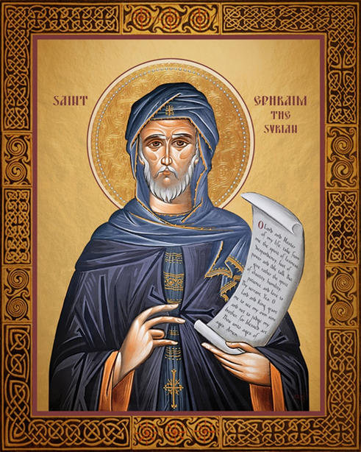

St. Ephrem of Syria

St. Ephrem lived from 306 to 373 AD. At his time, many heresies were being spread in the Church. In an age when many people could not read, heretics created songs to promote their false teachings. Songs also stick with us in a deeper way than spoken words and engrain themselves in our memory. Many people were falling away from the Church, so St. Ephrem, a deacon, decided to fight back. Amidst much persecution, he started composing beautifully poetic hymns that promoted the true teachings of the Catholic Church. Many believe his hymns inspired Dante’s writings. St. Ephrem is also credited with bringing hymns into the Holy Sacrifice of the Mass, which is still our tradition today. St. Ephrem died while ministering to plague victims and was proclaimed a Doctor of the Church in 1920. As his feast day approaches, let us reflect on what songs we listen to. The words of songs affect us in more ways than we can imagine and will affect the way we think and pray. May we always listen to songs concentrating on the good, true, and beautiful things of this world and the world to come.
This icon of St. Ephrem of Syria shows him holding his right hand with three fingers up and one down. This symbolizes his teachings of the hypostatic union, which is that Jesus had two natures, both God and man, but was one being. He is also holding a scroll, symbolizing his many writings. The prayer on this scroll is:
O Lord and Master of my life, take from me the spirit of laziness, despondency, lust of power and idle talk. But give rather the spirit of chastity, humility, patience, and love to Thy servant. Yea, O Lord and King, grant me to see my own sins and not to judge my brother, for blessed art Thou unto ages of ages. Amen.

