St. Francis Xavier
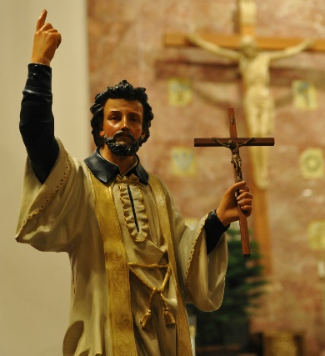
This week we celebrate the patron of missionaries, St. Francis Xavier. He most likely holds the record for most baptisms ever performed. In many instances he baptized so many people in one sitting that someone had to hold up his arm for him because it got too tired and weak. But if we look at Francis’ story, his college friends would be surprised he turned out a saint! Maybe some of us can relate. As a typical college student in any time, even the 1500s when he lived, Francis enjoyed the social scene. He wanted to enjoy the prestige and wealth that came with the life of a college graduate. But that gradually changed when St. Ignatius of Loyola became his roommate. Ignatius had a major religious conversion in his life, going from worldly soldier to aspiring saint. He supported and loved Francis as a good roommate should, but also pushed him to greater holiness saying, “What does it profit a man to gain the whole world but lose his soul.” Francis was stubborn though, and never took the faith too seriously. However, after three years of being roommates, their third roommate, St. Peter Favre, came back from a weekend away and found Francis a changed man. The man who had so stubbornly opposed Ignatius and ignored his soul for the sake of the pleasures of life was completely on fire with his faith. He seemed even more bought in than Ignatius! Ignatius’ prayers and petitions finally cracked his heart open to allow God in. So together, Ignatius, Francis, and Peter founded a religious order of priests, the Society of Jesus, or the Jesuits. The three also became inseparable best friends. They intended to be preachers around Europe, but the Pope called for the Jesuits to go to new lands, specifically Asia. There were so few of them, that they had to separate. Francis was chosen to be the main missionary in Asia. So, tearfully yet joyfully he left his brothers, knowing he would never see them again in this world. He went to India, making many converts and re-invigorating Catholicism since St. Thomas the Apostle was there. Next he traveled to Japan, where he found the people harder to talk to since he was poor and the Japanese highly valued wealth. Francis’s dream was to mission to China. However, exhausted from expending himself, he died on the way there. We have much to learn from St. Francis Xavier. Here is an excerpt he wrote to St. Ignatius:
The native Christians have no priests. They know only that they are Christians. There is nobody to say Mass for them; nobody to teach them the Creed, the Our Father, the Hail Mary and the Commandments of God’s Law. I have not stopped since the day I arrived. I bathed in the sacred waters all the children who had not yet been baptized. The older children would not let me say my Office or eat or sleep until I taught them one prayer or another. Then I began to understand: “The kingdom of heaven belongs to such as these.” I noticed among them persons of great intelligence. If only someone could educate them in the Christian way of life, I have no doubt that they would make excellent Christians. Many, many people hereabouts are not becoming Christians for one reason only: there is nobody to make them Christians. Again and again I have thought of going round the universities of Europe, especially Paris, and everywhere crying out like a madman, riveting the attention of those with more learning than charity: “What a tragedy: how many souls are being shut out of heaven and falling into hell, thanks to you!” I wish they would work as hard at this as they do at their books, and so settle their account with God for their learning and the talents entrusted to them. This thought would certainly stir most of them to meditate on spiritual realities, to listen actively to what God is saying to them. They would forget their own desires, their human affairs, and give themselves over entirely to God’s will and his choice. They would cry out with all their heart: Lord, I am here! What do you want me to do? Send me anywhere you like – even to India.
St. Francis Xavier, pray for us

