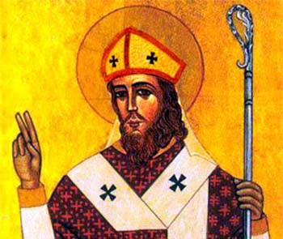
St. Hilary of Poitiers
This week we celebrate St. Hilary of Poitiers, Bishop, Doctor of the Church, and the Hammer of the Arian Heretics. Born in 310, he grew up in a wealthy pagan family. He received an excellent education, married a lovely wife, and had one daughter, later known as St. Abra. Everything in his life was good and normal, but he felt that he was searching for something. He realized only satisfying his desires with worldly pleasures wasn’t making him happy. He also realized when he went against any virtues, he felt guilty and unhappy. But he had heard so many theories of God, he didn’t know what to believe. He heard theories that God didn’t exist, there were many gods, God existed but didn’t care about his creatures, and God was found in creatures and images. But nothing seemed logical to him. Things finally clicked when he stumbled upon the Bible and read about God telling Moses “I AM WHO AM” (Exodus 3:14). He was amazed by such a clear definition of God, and knew this was the one true God. He then learned from the Gospel of John that Jesus was sent to bring eternal life to those who believed. He soon converted to Christianity with his wife and daughter. Shortly after he was named bishop of Poitiers, France by both the people and the clergy and was ordained a priest and bishop. He ministered to his flock well, and realized the Arian heresy was creeping in. He didn’t know much about the heresy, which denied Christ’s divinity as coeternal with the Father, but stood up for St. Athanasius when the Arians called for his excommunication. The Arians got mad at Hilary, and exiled him for four years. This was a bad idea for the heretics because in exile, Hilary had way more time to study, write, and combat the Arian heresy at its roots. He even wrote songs to combat the heresy. He concluded the Arian heretics “didn’t know who they were.” They got caught up in a heresy that they didn’t even understand and were fighting over words that had more meaning than they realized. Hilary caused such a stir in exile fighting the Arians, that the emperor kicked him back to Poitiers so he wouldn’t have to deal with the troublemaker anymore. However, Hilary didn’t go straight home and instead took a leisurely stroll through Greece and Italy to preach against the Arians with much success. At this time, the emperor also was persecuting Christians in favor of the Arians. However, Hilary, the Hammer of the Arians, lived long enough to see the death of the emperor and end of the Christian persecutions. His daughter, Abra, became a nun and fought the Arians in Poitiers while her father was in exile and died in 360 at around age 18. She later became a saint after spending her life working for the poor and defending the faith. Hilary himself died in 368 around age 58. While Arianism took over most of Europe at one point, it went underground in 381 and lingered until the 800s. We have much to learn from St. Hilary, the Hammer of the Arians. Are we comfortable and complacent in our lives of worldly pleasures as Hilary called “beasts happily grazing”? Or do we feel the call to look deeper and discover the true meaning of life, of who we are as found in God? Then, when and if we do find this truth, do our lives change? Do we act on it and stand up for it? Hilary didn’t have an easy life, but he knew the truth and stood up for it to the point of exile. Much of what he wrote and preached we now profess every Sunday in the Nicene creed. When we say these words, do we recognize how many people suffered, were persecuted, and even died so we could say those true words that expose who God is and what we believe? May we never take our faith for granted. St. Hilary of Poitiers, pray for us!

