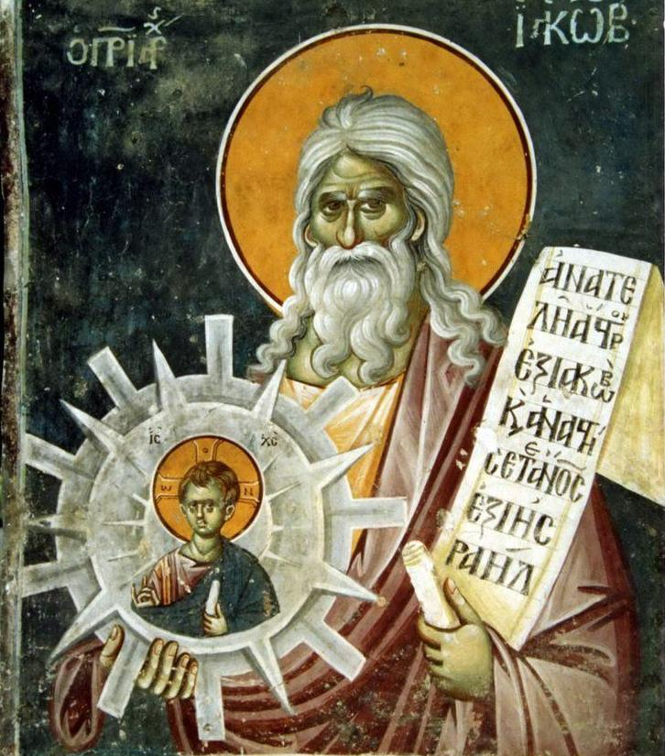
St. Hippolytus and reconciliation
We celebrate the feast of St. Hippolytus along with Pope St. Pontian this week. Anyone knowing these two during their lifetime in the early 200s would be shocked to hear they share a feast day. Hippolytus was a well known theologian with many published books and a renowned priest and preacher. Everyone highly respected him, and he was not afraid to state his opinions and correct others. However, his success and smarts added to his ego, and pride became his constant companion. This pride became a big problem when his ideas differed from the Pope’s teachings. Pope Pontian clarified and promoted the teaching that Christians that fell away from the faith, especially under the intense persecutions of the time, were able to go to confession and be reconciled with the Church. Hippolytus, however, believed that they were too far lost since they denied Christ when the chance came, thus proving that they were not true Christians to begin with. Hippolytus stuck by this teaching, and later this was identified as the Novatianism heresy. Hippolytus’ pride continued to grow, and he became so convinced of himself that he even stated Pope Pontian was not the true pope since he was teaching false views. Therefore, Hippolytus declared himself the real pope, thus making him the Antipope. This led to a schism in the Church. Hippolytus and Pontian were at odds, with neither budging until disaster struck. The Roman Emperor Maximinus Thrax hated the Christians and intensified persecutions. In 235 he exiled Pope Pontian and Antipope Hippolytus to the labor mines of Sardinia, which was usually a death sentence. Knowing he would die there, Pope Pontian became the first Pope ever to formally resign from the papacy and another successor was chosen smoothly. Together Pontian and Hippolytus suffered in the mines. During their time together, Hippolytus realized the error of his ways, confessed, and reconciled with Pontian, thus ending the schism in the Church. Side by side they toiled until Pontian was beaten to death and Hippolytus either died from exhaustion or abuse. Now they share a feast day together. Once enemies, they became brothers in their martyrdom. We can learn much from St. Hippolytus who overcame resentment and pride to seek reconciliation. The word resentment means to resend yourself through a traumatic encounter with another person. We do this all the time when we replay arguments or bad situations in our heads over and over again. We forget what actually happen and begin to let our emotions skew the reality in our memories. We then have much trouble forgiving others and moving on. Are we too stuck in our pride and ego to admit our mistakes? Do we hold grudges and do not seek or accept reconciliation? Maybe we are not fully in communion with the Church through one mortal sin or another. Do we seek the sacrament of Confession frequently, or do we refuse to acknowledge and confess our sins, leaving us apart from both God, the Church, and the community around us? We also learn from Pontian to stand by the truth. Even when it drives people away, we must stand up for the truth of the Catholic Church. Saints Hippolytus and Pontian, pray for us!

