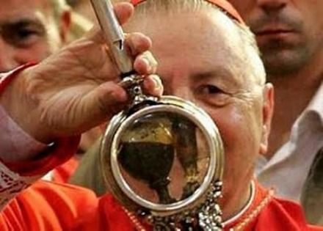
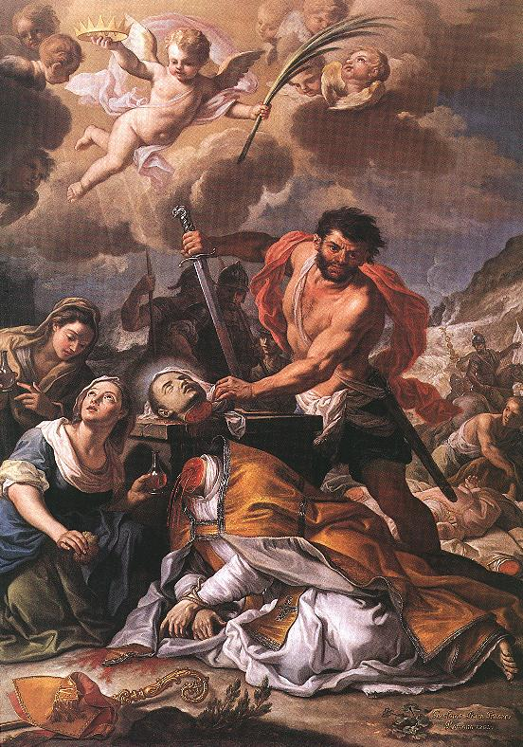
St. Januarius’ Blood
St. Januarius was born in the late 200s to a rich family in Italy. At age 15 he became the priest of his home parish, which was a pagan area. Later, at 20, he became the bishop of his home diocese of Benevento, Italy. He was a friend of St. Juliana of Nicomedia and St. Sossius. The emperor Diocletian persecuted Christians, and Januarius would hide Christians and minister to them in prisons. While visiting Sossius in prison, Januarius was caught. Some say he was thrown to wild beasts, who refused to eat him. Then he was thrown into a fiery furnace, but emerged unscathed. Finally, he was beheaded and died, but some of his blood was collected by a woman named Eusebia and stored in two vials to be reverenced as a relic.
Now, St. Januarius is most famous for his blood. The two vials are stored in a reliquary in the Naples Cathedral and liquefy at least three times a year. The dried blood will liquefy on September 19—his feast day, December 16—celebrating his patronage of the Archdiocese of Naples, and the Saturday before the first Sunday in May—the day his relics were reunited. It also spontaneously liquefied for the visit of Pope Pius IX in 1848 and half liquefied for Pope Francis in 2015. The whole city gathers each of these days to see the liquification. The Archbishop holds the vial, and turns it upside down. When it liquifies, it will run down to the bottom of the vial. The blood always rehardens after every time. We have an important lesson to learn from St. Januarius. Namely, that Saints are still alive in heaven and love us and pray for us! They are present at every Mass with us and want to help us! St. Januarius shows us this with the miracle of his blood. May we always look to the intercession of the Saints and use them as our models for our lives! St. Januarius, pray for us!

