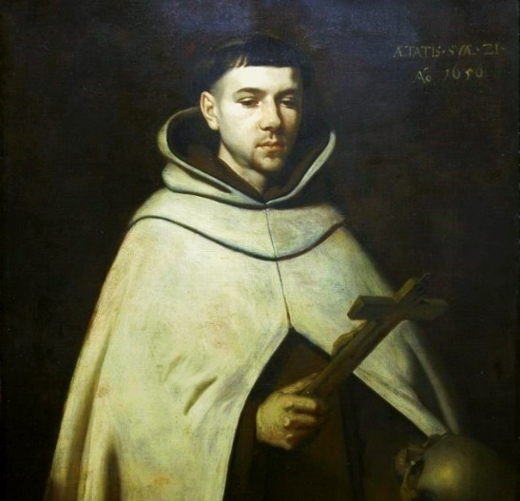
St. John of the Cross
Earlier we learned about St. Teresa of Avila. Now we celebrate her spiritual brother, St. John of the Cross. John was born in Spain in the mid 1500s. His father died when he was just 2 years old, leaving the family penniless. His older brother probably died of malnutrition. His mom moved the family to find work, and John was unsuccessful at many trades. He did work in a hospital with Augustinian nuns and learned much about medicine. However, he was a child prodigy when it came to school. He excelled even at the university, where most thought he would continue in academics. However, he felt called to religious life and joined the Carmelites to the dismay of many professors, taking the name John of St. Matthias. He did continue to study as a Carmelite. John , however, was discontent with the lax attitude the Carmelites had adopted, so he thought of transitioning to a Carthusian monastery known for it’s stricter observance of silence and rules. However, he met St. Teresa of Avila before he could join, and she convinced him to help her reform the Carmelites. They were odd friends with Teresa being extremely animated and outgoing and John being more reserved and academic. And sometimes they really just didn’t understand each other. But both knew they were striving for holiness and helping each other spread the love of God. John did found a monastery that followed Teresa’s stricter rules, and he took the name, John of the Cross. As tensions among the differing Carmelites mounted, John became more and more a subject of persecution. Soon, his own previous Carmelite brothers broke in and took John prisoner. He was kept in a cell under extremely sparse conditions in a monastery. He received lashings weekly, was completely isolated, had only the clothes on his back, and was fed only water, bread, and scraps of salt fish. At first John accepted his circumstances as a form of penance. He wrote many beautiful spiritual works during this time and had much time to delve into the spiritual life. He experienced union with God in his imprisonment. However, after 8 months he realized he was close to death and God was calling him to escape. So John pried the door off the cell and escaped through a small window in an adjoining room. He showed up at Teresa’s convent half dead, but immediately asked for pen and paper to write of God’s immense love. Teresa’s nuns tried to nurse John back to health, but he had to spend 6 weeks in a hospital to fully recover. After he recovered, John spent the rest of his life reforming the Carmelite order, founding new monasteries, praying, and writing. He is the author of many classic works. He died at the age of 46 from a skin infection and was canonized and made a Doctor of the Church. He also is considered one of the great Spanish poets and authors from a secular perspective. John is most noted for his writings on the spousal love of God and the dark night. The spousal love of God for each person is the truth in which each human is analogous to a bride and God is the groom, always pursuing his bride. John wrote many love poems describing this love. He also wrote how to achieve this intimate union with God, or spiritual marriage, which requires dark nights. The dark nights are what he used to describe the soul detaching from the world in order to experience deep union with God. One part he describes is the dark night of the senses in which all the senses are dark and detached, but the soul is alive and able to experience spiritual realities in a deeper way. May we also be able to experience the spousal unitive love God has for us! St. John of the Cross, pray for us!

