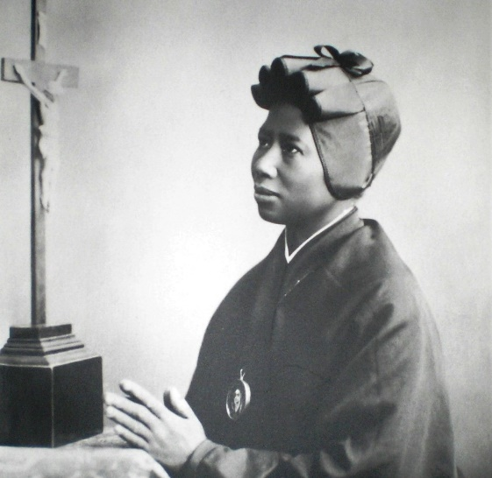
St. Josephine Bakhita
This week we celebrate the feast of St. Josephine Bakhita. Bakhita was born in what is now Sudan in 1869 to a well off family. She lived a happy, carefree childhood until she was kidnapped by Arabs and sold into slavery at 7 years old. She was forced to walk barefoot over 600 miles and was forced to convert to Islam. The trauma she experienced caused her to forget her name, so the traders called her bakhita, Arabic for lucky or fortunate. She was traded over 12 times all throughout Africa. Sometimes she was treated well, but mostly she was not. One owner whipped her so often she said “I do not recall a day that passed without some wound or other. When a wound from the whip began to heal, other blows would pour down on me.” The most terrifying experience she had was being branded with scars. This common practice was used on most slaves. Flour was used to draw patterns on her skin, then they cut deeply the patterns with a razor. Finally, the wounds were filled with salt to ensure permanent scarring. Bakhita had 114 intricate patterns cut into her breasts, belly, and right arm. Finally at age 14, Bakhita was given a reprieve when she was bought by a kind Italian government official. He did not beat or punish her, and eventually moved his family, along with Bakhita, back to Italy. In Italy, Bakhita was given to a new owner, who was also kind, and became a nanny to his young daughter, Alice. She made one more trip back to Sudan with this family for nine months. When her owner decided to move back to Sudan permanently, things grew complicated and Bakhita and Alice were left under the care of the convent of the Canossian Sisters in Venice while her owner and his wife arranged affairs in Sudan. While there, Bakhita encountered Christianity for the first time. She was particularly struck by the crucifixion because in Sudan, only slaves were crucified as punishment. How then, could this religion worship a crucified man? She felt these sisters showed her “heroic patience, and introduced me to that God who from childhood I had felt in my heart without knowing who He was.” When her owner came back to take his slave and daughter to Sudan, Bakhita was torn. Her heart was in Africa, but she found Christ. Bakhita decided she wanted to stay in Italy, become a Christian, and join the Canossian sisters. Her owner tried to force her to move with them, but the Italian court ruled that since the British had outlawed slavery in Sudan before Bakhita was born and Italy never recognized slavery, Bakhita had never legally been a slave and was free to do as she chose. In control of her own life for the first time at age 21, Bakhita was baptized as Josephine Margaret Fortunata and entered the Canossian sisters at age 24. From there, she quickly was recognized for her sanctity, gentleness, and smile. She always had a missionary heart and prepared many sisters for mission in Africa. Her sisters said, “her mind was always on God, and her heart in Africa.” The town came to revere her, and credited her prayers with their protection during WWII when not a single causality was incurred. Probably as a result of previous harsh treatment, Bakhita’s old age brought much physical suffering, and her mind sometimes returned to the terrors of slavery. However, whenever she was asked how she was she replied, “As the Master desires.” A young student also asked her what she would do if she met her captors. She replied without hesitation, “If I were to meet those who kidnapped me, and even those who tortured me, I would kneel and kiss their hands. For, if these things had not happened, I would not have been a Christian and a religious today.” With such recognition of Divine Providence and forgiveness, Bakhita died in 1947. She was canonized in 2000 by St. Pope John Paul II who commented that she was “the daughter of Sudan sold into slavery as a living piece of merchandise and yet still free. Free with the freedom of the saints.” The news of her beatification was banned by the government in Sudan, and many Sudanese Christians today are still heavily persecuted. Modern day slavery also is still a problem with 40.3 million people living in slavery. That is three times more slaves than any other point in history. Half of these slaves are forced into labor. Many slaves are also sex slaves or child soldiers kidnapped as children, beaten, abused, and drugged. Kentucky has between 100 and 200 victims of sex trafficking a year while typically states with big cities and major interstates have thousands. The super bowl is the most prolific day for the sex trafficking industry in the United States. May we pray for a greater respect for life and end to modern day slavery everywhere. May we also live as Bakhita, recognizing God’s hand even in our darkest times, and seeing our faith as more valuable than all the sufferings in the world. St. Josephine Bakhita, pray for us!

