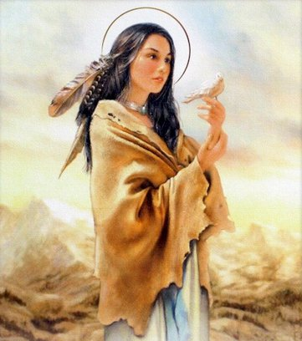
St. Kateri the Rebel
St. Kateri Tekakwitha was born into a Mohawk village in 1656. Her village had previously tortured and killed Catholic Jesuit missionaries. She was given the name Tekakwitha, which means she who bumps into things. Her father was a Mohawk chief, and her mother was a Catholic woman captured from an Algonquin tribe during a raid. When she was 4, a smallpox epidemic went through her tribe and Tekakwitha was left orphaned with facial scars and impaired eyesight from the smallpox. She was given to the care of uninterested relatives, where she was worked and ridiculed. Her tribe was unstable with much violence between other tribes and colonists, but a French priest was there instructing many in the faith. Over and over again, Takakwitha was pressured to marry by her relatives, but she consistently refused, even under threats and harsh workloads. She would also help the priest Fr. Pierron, in tending to the sick, wounded, and captives of war. The Mohawks typically intensely tortured all captives-both men and women- for four days, killing them on the last. Fr. Pierron, Tekakwitha, and a few others would care for the captives and comfort them as best they could before their death. For her care for the captives, continual refusal of marriage, and overall piety and gentleness, Tekakwitha was constantly ridiculed and made fun of. She consistently went against the culture of her tribe, and for that was considered rebellious and weird. Another French priest, Fr. Lamberville, baptized Tekakwitha with the name Kateri, after St. Catherine of Sienna, at age 19. He stated she did everything she could to stay holy in a secular society, which often caused minor conflicts with her longhouse residents. After her baptism, some of her tribe opposed her and accused her of sorcery. To escape, she went to live at the Jesuit mission with other Catholic converts. There she learned of religious sisters and expressed her long held desire, “I have consecrated myself entirely to Jesus, son of Mary, I have chosen Him for husband and He alone will take me for wife.” At the mission, Kateri continued to grow in holiness, surrounded by many others who supported and mentored her. She took on many penances to offer up for the conversion of her family and tribe. Kateri died in 1680 at age 24. Her scars disappeared upon her death, and her face became radiant. After her death, she also appeared in visions to her mentors at the mission. She is the first Native American to be canonized a saint. As we celebrate St. Kateri this week, let us examine our own lives. Do we live our faith, even when it is counter-cultural? Or do we let the culture determine our lives? Do we choose the right and holy things even when we are ridiculed? Or do we put more worth in the thoughts of others than in the thoughts of God? St. Kateri Tekakwitha, Lilly of the Mohawks, pray for us!

