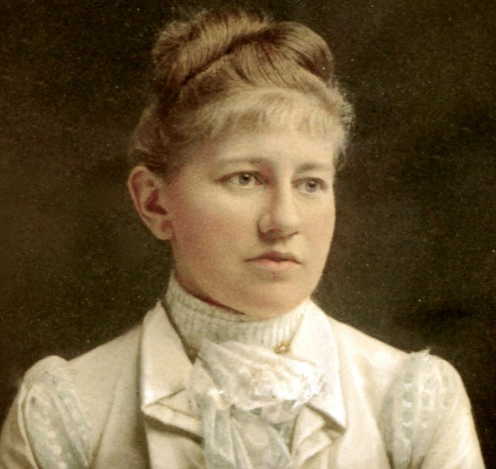
St. Katharine Drexel
This week we celebrate the feast of St. Katharine Drexel, the second US citizen born in the United States to be canonized. Katharine was born in Philadelphia in 1858 to a pious wealthy investment banker. Her mother died a few weeks after her birth, but her father remarried two years later. Born into high society, Katharine and her two sisters were highly educated by a private tutor, yet the family also distributed food and alms three times a week to the poor. As a young wealthy woman, Katharine’s highly anticipated social debut came about in 1878. However, she watched her stepmom fight cancer for three years and finally succumb to the illness. This experience struck Katharine as she realized money could not prevent pain or death. She began to see life differently and wanted to help others. From her travels around the US, she noticed the plight and destitution of many Native Americans and African Americans and was determined to help. When her father died in 1886, he left Katharine and her two sisters a $15.5 million estate (modern day $400 million). At this point, the sisters started founding and funding educational institutions and missions for orphans, Native Americans, and African Americans. Katharine, still the high society socialite, received many marriage proposals, yet also desired to join a convent. In an audience with the Pope the sisters asked for missionaries to staff their missions, but the Pope looked at Katharine and suggested she be the missionary herself. After much discernment, Katharine entered a convent, shocking the society she left. The newspapers headlined “Miss Drexel Enters a Catholic Convent—Gives up $7 million.” Shortly after entering the convent, Katharine established a new order, the Sisters of the Blessed Sacrament for Indians and Colored People, now known as the Sisters of the Blessed Sacrament. From there, the order courageously and tirelessly worked. Under Katharine’s leadership, they established 145 missions, 50 schools for African Americans, and 12 schools for Native Americans. Xavier University of Louisiana, the only historically black Catholic college in the US is among those schools. The sisters focused on education and translated the Catechism and other works into different Native American languages. The sisters, however, did meet persecution. Shortly after moving into their first convent house, the sisters found a stick of dynamite in the yard. Another time the sisters met persecution from the Klu Klux Klan. The KKK is very anti-Catholic and anti-African American, so they really hated the sisters. They threatened to tar and feather the pastor at one of Katharine’s missions. The sisters prayed for protection for the pastor, and later a tornado came, destroyed the KKK headquarters, and killed two members. They never threatened the sisters again. After giving her life and fortune to God in defense of the poor and destitute, Mother Katharine Drexel died at age 96 in 1955. She was canonized in 2000 by Pope Saint John Paul II for her love of the Eucharist, perspective of the unity of all people, courage and initiative in addressing social inequality among minorities more than 100 years before the civil rights movement, her work for quality education for all, and her selfless service, including the donation of her inheritance, for the victims of injustice. The Sisters of the Blessed Sacrament continue their mission today, but on a much smaller scale with only 100 sisters left. We have much to learn from St. Katharine. First, do we recognize the true value of money, as a gift from God, entrusted to us, to be used for His ends? Do we realize money will not buy happiness, safety, invincibility, or heaven.? Would we be willing to give up a high society, posh, millionaire lifestyle to stand up for the life and dignity of the destitute, vulnerable, and forgotten? The world thought Katharine was crazy for throwing everything away for God. If we are living a life that the world doesn’t think is crazy, maybe we need to reevaluate our life and see if we are willing to live totally for God. St. Katharine Drexel, pray for us!

