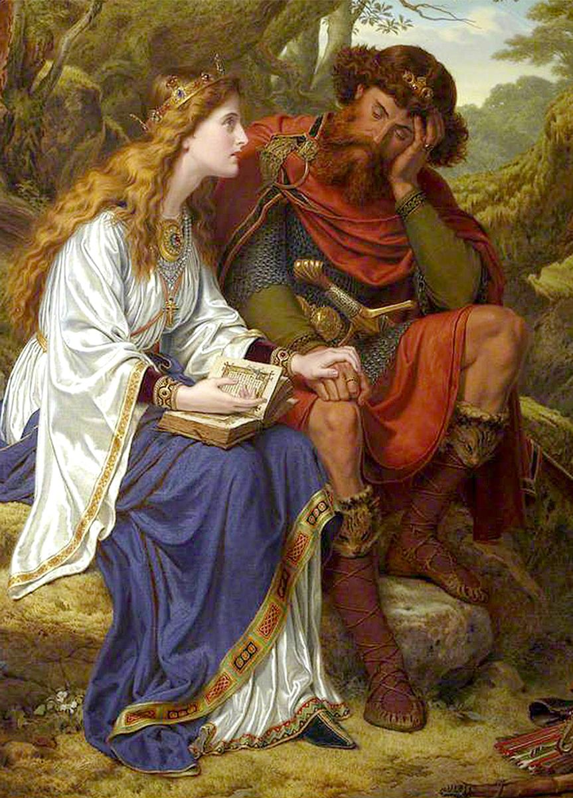
St. Margaret of Scotland
This week we celebrate St. Margaret of Scotland, Queen of the Scots. It’s not too often that we hear about saints that were royalty. Probably because power can corrupt even the most well intentioned people. But Margaret had uncompromising virtue and love. She was born in 1045 in Hungry to the exiled King of England. At age 12, her father took his family to reclaim the throne of England. However, he died upon arrival, the Normans invaded, and so her mother fled with the children. They intended to go back to Hungary, but shipwrecked in Scotland when Margaret was 21, where King Malcolm welcomed and protected them. Malcolm soon fell in love with Margaret, and she married him at age 25. They had eight children, including three future kings of Scotland. As Queen of Scotland, Margaret led many souls to God, starting with her husband. She encouraged him to practice more virtue, and would read him the Bible since he was illiterate. He responded by binding Margaret’s sacred books in gold, silver, and jewels and kissing the ones he loved most. Together they lived a life of piety and holiness, raising their children to be holy as well. Next, Margaret moved to the court, cleansing it of gossip, scandal, and immorality. For the people, Margaret and Malcolm together would serve the poor every day before they ate, and washed their feet in imitation of Christ. During Lent and Advent, they would do this on their knees. This also served as a fantastic example of holy marriage, and many other citizens were inspired to do likewise with their families. Margaret also fought against the scandal and sins of the clergy, supporting synods and founding churches and monasteries. Malcolm also went to Margaret for advice on how to run the country. After serving her family, the people, and the church tirelessly for so many years, Margaret weakened at age 50. Her husband and oldest son were killed in an attack that year, and Margaret died four days later.
When looking at our politicians, leaders, and even some clergy today, it is easy to see how power can corrupt even the most good-willed people. So, how did Margaret, Queen of Scotland, take her beauty, power, wealth, and influence to use only for the greater glory of God? She had a rough childhood, was a refugee, was no nun, and married a worldly man with a worldly court. Yet she sanctified her family, the country, and the clergy. Her secret was prayer, fasting, and virtue combined to make holiness. The word “holy” means in Hebrew to be different, or set apart. Praying for an hour and reading the Bible every day is not normal. Fasting everyday is not normal. Going to both Sunday and daily Mass is not normal. Living a virtuous life is not normal. But Margaret was holy, not normal. And she did all these in heroic ways. As Pope Emeritus Benedict XVI stated, “You weren’t made for comfort. You were made for greatness.” And that is how this laywoman became a great saint! So, are we willing to put aside the “normalcy” and comfort of our lives to be great? Are we willing to take the time to pray, fast, and practice virtue to be a saint? St. Margaret of Scotland, pray for us!

