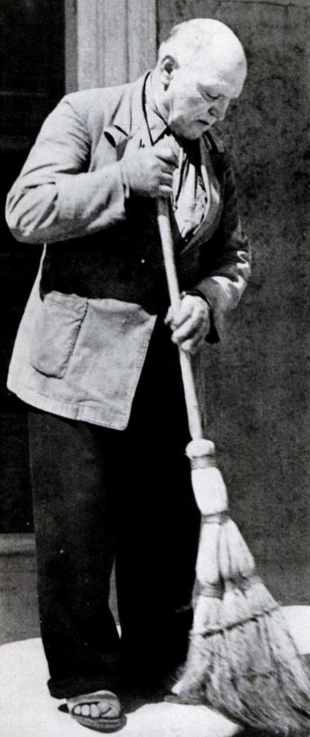
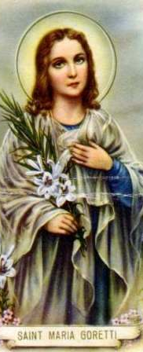
St. Maria Goretti and
Forgiveness
St. Maria Goretti was born into a poor Italian family in 1890. Her family worked and lived on the land of the Serenelli family. One of the Serenelli’s sons, 20-year old Alessandro, became addicted to pornography and let his lust rule his life. While watching the 11-year old Maria walk down the road one day, he let his lust overtake him, and tried to rape her. Maria resisted and told him to think of the fate of his own soul. When he didn’t get his way, Alessandro stabbed Maria 14 times. Maria died shortly after, but before she passed said, “I forgive Alessandro Serenelli … and I want him with me in heaven forever.” Alessandro went unrepentant to prison. However, one day in his cell, Maria appeared to Alessandro and forgave him again. This time, Alessandro was changed. He realized his sin and repented. After 27 years in prison, he went to Mass with Maria’s mother and asked her forgiveness. He then went to live at a Franciscan monastery where he prayed and worked as a gardener for the rest of his long life. He always referred to Maria as his angel, since she forgave him and led him back to repentance and God. Alessandro died in 1970 at the age of 88. Before he died he wrote about his young life saying, “Looking back on the past, I recognize that, in my early youth, I went down a false path: the way of evil, which led me to ruin. I saw the world through the news, entertainment, and bad examples that most young people follow without giving them a thought: I didn’t think about it either.” On his deathbed Alessandro wrote, “And now, with serenity, I await the moment of being admitted to the vision of God, of embracing my loved ones again, of being near my protecting angel [Maria] and her dear mother, Assunta.” Now, Alessandro is being considered for sainthood. Many hope he will be the patron saint of those struggling with pornography and sexual sin. Let us consider our lives in light of St. Maria Goretti and Alessandro Serenelli. Alessandro’s addiction and lust led him to a vile and evil sin. Yet, Maria’s unsolicited forgiveness led him back to God. Do we let our sin and passions rule our lives? Do we seek repentance and beg God for his grace and mercy? Or do we remain complacent in our sin, justifying it to ourselves? Are we like Maria in forgiveness, giving it when it isn’t even asked? Or do we let hatred and resentment control us? St. Maria Goretti and Alessandro Serenelli, pray for us!

