St. Martin of Tours
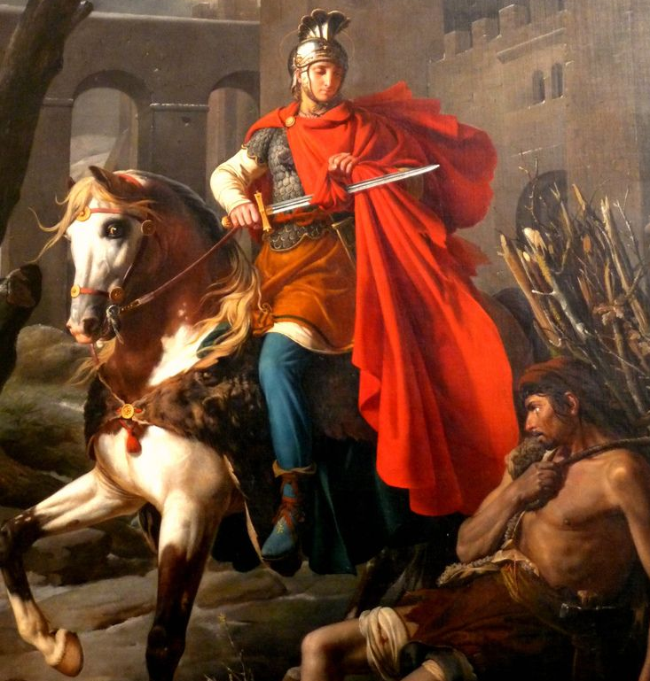
This week we celebrate St. Martin of Tours’ feast day. Martin was born around 316 in the Roman Empire to a senior officer in the Roman army. Martin followed in his father’s footsteps to become a soldier as well. At age 10 he encountered the newly legalized Christian religion and decided to study to be baptized against his parents wishes. At 15, Martin joined the calvary and at 18 joined the elite calvary that escorted the emperor on travels. Basically Martin was in the secret service of the time. Sometime around age 18, Martin, who was still studying to be baptized, was riding his horse through Gaul in the winter. He encountered a freezing beggar, drew his sword, and cut his cloak in half to share with the man. That night he dreamed that the beggar was Jesus who said, “Martin, who is still but a catechumen, clothed me with this robe.” Martin was eventually baptized and continued his military career until about age 45 when the Christian emperor died and Julian the Apostate took the throne. Julian had been Christian, but denied Christianity and tried to bring paganism back at the expense of Christians. Martin heard the news right before battle and refused to fight for the new emperor. He said, “I am a soldier for Christ.” He also refused any pay from the new emperor. Charged as a coward, he was jailed, but volunteered to go to the front of the troops unarmed to prove his courage. His superiors let him, but the enemy sued for peace and a battle never occurred, so Martin was released from military service around age 45. He became a monk and friend of St. Hilary of Poitiers, a Doctor of the Church and adamant fighter against the Arian heresy. Martin also traveled, preached, and establish monasteries. Word of his holiness spread, and the village of Tours decided to make him their bishop. Martin didn’t want to be bishop, so he hid in a barn full of geese, but the geese made a lot of noise and informed the villagers of Martin’s hiding spot. So, he was ordained a Bishop. As Bishop, Martin lived in a cave that was part of his monastery and visited each of his parishes at least once a year. He also spent much time converting pagans and tearing down pagan temples, altars, and sculptures. In one instance he tore down a pagan temple, with the worshippers standing quietly by. However, when he attempted to cut down their sacred pine tree, they began to oppose him and wouldn’t let him do it. Finally, the pagans agreed that they would cut down their pine tree if Martin would stand directly in its path. Martin agreed, the tree was cut down, and miraculously missed Martin. Everyone was astonished, and many pagans converted. Martin continued to serve as the beloved Bishop of Tours until his death in 397. One final story of Martin involves a vision he had. Martin saw an image of Jesus standing before him. Martin then spat upon the image of Jesus and told him to go away. The image frothed with rage and asked Martin why he did that. Martin said, “you are not Jesus, you are the devil!” Raging, the image turned into the devil and asked Martin how he knew that. Martin said, “you have no wounds on your hands, feet, or side. Jesus always bears His wounds, because they are the wounds of His love for us. You, the devil, will never bear wounds for anyone, because you would never sacrifice yourself for the sake of another.” Then the devil left Martin.
Let us learn from Martin to have courage, live a life of service, and be willing to bear wounds for the sake of others. St. Martin of Tours, pray for us!

