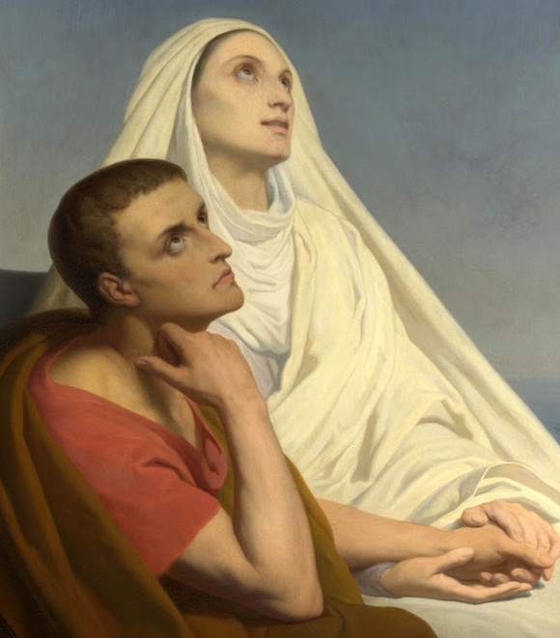
St. Monica of Hippo
This week we celebrate the feast of St. Monica and her son, St. Augustine. Both have much suffering and redemption in their stories. St. Monica was born in Northern Africa to wealthy Christian parents in a town with much Italian influence. Her childhood chore was to fetch wine from the casks in the cellar. She would sneak a drop every time until a drop became a lot, and she became an alcoholic in her tween years. Her parents married her off to an important pagan official, Patricius. He had a violent temper and was probably also an alcoholic with abusive and adulterous tendencies. He also criticized Monica for her Christianity, but still respected her for her kindness and unceasing love. Monica grew deeper in her faith and overcame her alcoholism. She and Patricius had three sons, one being Augustine. She wanted to baptize them, but Patricius refused. Augustine was highly intelligent, but also dissolute. He lived with a woman for many years and fathered her child. He also fell into the Manichean religion, which was a combination of Christianity and pagan religions. Monica was distraught over her son’s soul. She prayed and fasted intensely. Legend says she cried every night over Augustine. One bishop told her “the child of so many tears shall never perish.” Monica also prayed and fasted for her husband and mother-in-law. Both of them converted and were baptized close to their deaths. After they died, Monica focused solely on Augustine who was busy pursuing his rhetorician career. She followed him everywhere he moved, to his dismay. He even tried eluding her, but she always found him. Eventually Augustine and Monica met St. Ambrose. Augustine was slowly converted and became a priest and eventually a saint, theologian, author, and doctor of the Church! Monica saw her son’s conversion and died not too long after. She is the patroness of married women, difficult marriages, disappointing children, victims of adultery, victims of verbal abuse, and conversion of relatives. All of us have some family members who walked away from the faith, or never accepted it in the first place. Let us remember to never give up hope and fervently pray and fast for them. No one is too far gone to receive God’s mercy. Let us also recognize the power of prayers. God has crazy plans when we keep praying. So many great sinners became great saints. Therefore, let us also recognize the power of prayer. Furthermore, Monica could’ve become a bitter and nagging wife and mother, disappointed in her life and embarrassed by her family. However, she continued to be filled with charity, patience, perseverance, and humility, continuing to love and serve her family. May we follow her example. St. Monica and St. Augustine, pray for us and our families!

