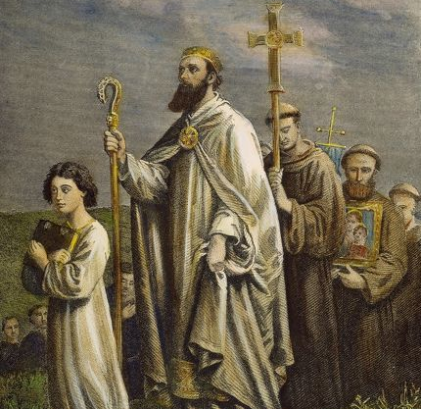
St. Patrick of Ireland
This week we celebrate the well known feast of St. Patrick. Even our secular world loves celebrating St. Patrick, but many don’t know the man behind the celebration. Patrick was born in the 400s in England to a wealthy Christian family. His grandfather was a priest and his father was a deacon. He, however, did not give any attention to his faith and considered himself a non-believer. Sometime around his youth he also committed a sin so grave that others held it over his head up until his death. Many believe this sin was murder, that Patrick had killed a man. God, though, had an elaborate path to bring Patrick back to Him, and Patrick was kidnapped by Irish slave traders at age 16. Sold in northern Ireland to a man who fed him with the animals and beat him, Patrick was left to tend the flocks. His shaved head showed he was a slave, and he was exposed to the elements. It was here, away from the comfort and luxury of his former life, that Patrick encountered God. God became his constant, and only companion, and Patrick learned the depths of prayer and redemptive suffering. He pledged his life to God and was at peace with his circumstances, for they allowed much time for prayer. He was shocked when at age 22, a voice told him to escape and run to the coast, for a ship would take him home. He ran away and found the ship, but they wouldn’t take him for he had nothing to pay with. He turned away to return to his master’s flocks, but the sailors called after him and took him aboard. They landed in a desolate area of Britain and wandered for a month, running out of food. The sailors mocked Patrick for his God did not provide, but Patrick replied that nothing is impossible for God, and a herd of wild boar appeared shortly after. They ate and gained strength to continue their travels. Sometime Patrick escaped from this group and returned home to his parents There, with his newfound faith, Patrick studied for the priesthood and was ordained a priest. He kept having visions and hearing cries of the Irish people pleading, “we entreat thee, holy youth, to come and walk among us once more.” Patrick asked his superiors to send him to Ireland, so they sent him off alone to evangelize the island of Ireland. Patrick was 40 when he arrived. He was run off from his first arrival, but eventually found a spot to land and celebrate Mass. He was found by a local chieftain who was struck by Patrick’s piety and peace. He and his tribe were Patrick’s first converts. Patrick then went to the high king of Ireland to ask his permission to evangelize in the land. The king never converted, but gave his permission, and Patrick travelled all over the island making converts. He even went to his old slave master to convert him, but he was too proud to receive him and set his house on fire, dying in the flames. Patrick did meet persecution, and once his chariot driver took a spear meant for him. Despite the persecutions and sufferings Patrick endured, he effectively evangelized and converted the entire island of Ireland in his lifetime, starting at age 40. He was also ordained Bishop of Ireland whenever it was considered there were enough Catholics to need a bishop. He had a strong, bold, and convincing personality, yet struck people with his peace and devotion. While the shamrocks and snakes make good stories for St. Patrick, let us not forget who this suffering, sinful, powerful, and charismatic man really was. The man who loved his persecutors so much, to live his life for their eternal life. It is said, “all men of Ireland, living or dead, shall be blessed and consecrated to God through Patrick.” May we imitate his bold and holy example. St. Patrick, pray for us!

