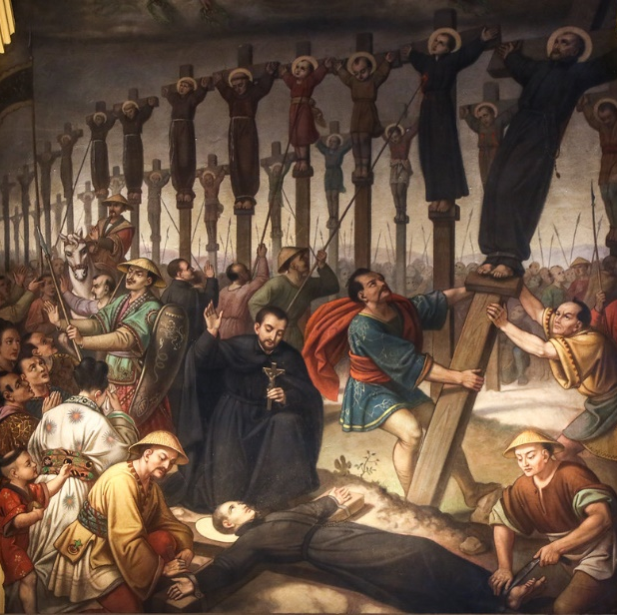
St. Paul Miki & Companions
This week we celebrate the feast of St. Paul Miki and his 25 companions who were all martyred together. Not too long after St. Francis Xavier had brought the faith to Japan, Paul was born in the 1500s to a Japanese military leader. He was highly educated, and was on track to become a samurai, but instead joined the Jesuits in 1580. Known for his eloquent preaching, he converted many to Catholicism, yet didn’t live long enough to become a priest. Things became difficult when the ruler of Japan at the time, Toyotomi Hideyoshi, started persecuting Christians. Many Jesuit missionaries had come from Europe to evangelize, so Hideyoshi believed Catholicism to be a spy network for Europe. Even though Catholicism had been well established among the Japanese people and many priests were Japanese natives, he still believed it to be a foreign influence and started killing them. Paul was rounded up in a Christian hunt with 25 other people. These 25 others included priests, workers, artists, and even children. Their captors cut off their left ears as a sign of disrespect and forced them to march 600 miles to Nagasaki. They sang God’s praises the whole march, and many spectators were converted through their witness. When they finally reached Nagasaki, they went to a hill overlooking the town, and the guards set up crosses. Paul and his companions were then crucified on the crosses with their hands and legs tied and their necks bolted by iron. Crucifixion is death by asphyxiation because your body becomes too weak to hold yourself up, so you cannot breath and suffocate to death. On the cross, Paul, ever the preacher, realized this was his most glorious position and preached. He openly proclaimed that he was Japanese, not foreign, and was only being killed for being Catholic and proclaiming Christ, which he was proud of. He also forgave his executioners after the model of Christ, encouraged his companions in their final struggle, and prayed his blood would fall on his fellow men as fruitful rain. As they awaited death, they sang the Canticle of Zachariah. After they finished, their executioners thrust spears into their sides and killed them all. They were the first martyrs of Japan in 1597. All the Catholic priests were killed or deported, and no trace of Catholicism was left. However, almost 300 years later in the 1860s, Catholic missionaries returned to Japan. After they had established themselves for a while, they started having people ask them strange questions. They asked, “do you pray in honor of the lady?” and “does your father live in Rome?” It took the missionaries a minute, but they realized these Catholics were asking about Mary and the Pope. When they answered yes to the people, they started crying and rejoicing that priests finally returned! They had stayed in hiding for so long, even using hollowed out Buddhist statues to hide rosaries and crosses. Today, Catholics only make up one percent of the population of Japan, but they are most numerous in Nagasaki, the same place Paul and his companions were martyred. His blood did fall as fruitful rain, and Catholics today in Japan can practice their faith in peace. Even non-Catholics have adopted Christian customs like Christmas, exchanging wedding vows in chapels, and St. Valentine’s day. May we also be willing to give our lives for the faith! St. Paul Miki and companions, pray for us!

