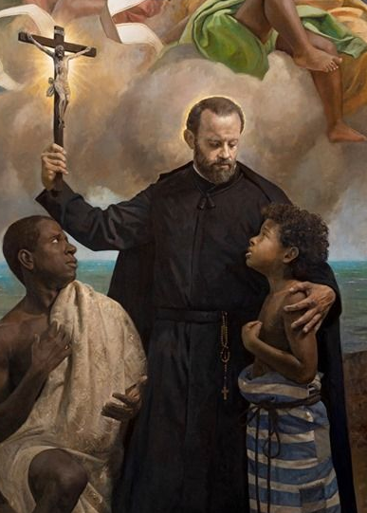
St. Peter Claver, the Slave of the Slaves Forever
St. Peter Claver was born in 1580 into a devout Spanish farming family. He was known for his intelligence and piety, and early on believed he was called to completely serve God with all his being. He became a Jesuit priest and volunteered for the missions in the Spanish colonies in modern day Columbia. In the new world, Peter encountered the harsh reality of slavery. In the port city where Peter lived, 10,000 slaves were brought in every year from Africa. About 1/3 of the slaves died in transport from Africa to the Americas due to the horrendous conditions on the ships. Two popes had already condemned slavery, but it continued. Peter felt drawn to help and called himself the servant of the Africans and learned their languages and customs. Later he called himself the slave of the slaves forever. Every time a new ship would come in to port, Peter would go to the cargo hold and minister to the Africans. He would treat their illnesses and wounds and comfort them. The rumors were that they would be hauled onshore and eaten, so many were frightened. As they were taken onshore, Peter would bring them food, bread, brandy, lemons, tobacco, and medicine and give them basic instruction in the faith. He called them all brothers and sisters, and encouraged them to see him as a brother as well. It is estimated that he catechized and baptized over 300,000 slaves. During the off season when the ships wouldn’t come, Peter would travel to the plantations, visiting the slaves. Many of these were people he already had baptized, and it is estimated that he heard over 5,000 confessions a year. On his visits, he would live with the slaves and ensure they were treated humanely. He also preached all over the city, encouraging the recognition of the human dignity of the slaves, and ministering to all different members of society. After an exhausting 40 years of toil, Peter fell ill and couldn’t leave his room for 4 years until his death. During this time an ex-slave cared for him, but physically abused him and starved him. Peter never complained, but saw it as a just punishment for his sins. We have much to learn from St. Peter. He spent his life serving people who were considered the lowest of society, and made himself even lower. He encountered people in the worst of conditions, an d lifted them up. He believed all people deserve to hear the Gospel, and saved hundreds of thousands of souls. And finally, even though he was treated unjustly in his illness, he never complained. May we have the same humility and courage! St. Peter Claver, pray for us!

