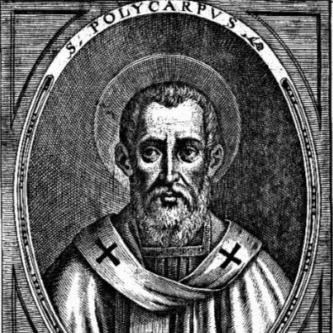
St. Polycarp
This week we celebrate the feast of St. Polycarp, whose name means “much fruit”. He was a disciple of St. John the beloved apostle, who taught him the Christian faith and ordained him a priest and later as Bishop of Smyrna, in modern day Turkey. While Polycarp never knew Jesus, he heard about him firsthand from John and the other apostles, as he was friends with them as well. Polycarp was also good friends with the St. Ignatius of Antioch and St. Clement I, the 4th pope. These three men became instrumental in the early Church. When Jesus died, only the 11 remaining apostles really knew all that He did and said. They went off evangelizing and drew followers in who they told and taught all that Jesus said. Polycarp, Ignatius, and Clement were the main three they taught. When the apostles then died, the faith sat in their hands, along with the guidance of the Holy Spirit of course. Previously, no one had written down how to say Mass, what Jesus said, or what Christians believed, so much confusion and heresies were spread in the Church. Polycarp, however, had spent much time with the longest living apostle, John, and knew all the information. Therefore, he set about correcting all the heresies, promoting the true faith, and writing things down. He was known to be such a great preacher and teacher that no one could stand in his way. Polycarp did this for most of his 86 years of life, and won a great reputation for authority and sanctity. When persecutions drew near, he evaded them for a long time, and no one really wanted to pick on an old man. But, one emperor decided the Christians really needed a lesson and ordered Polycarp captured. Knowing he was being hunted, Polycarp hid as long as possible, but was finally caught in a house. When his captors came, he prepared a meal for them and hosted them kingly. The captors wondered how such a nice old man could be an enemy of the state, but they had orders from the emperor. When brought to the emperor, many pleaded with Polycarp to deny Christ, but Polycarp refused and replied, “Eighty and six years I have served Him, and He has done me no wrong.” Enraged, the emperor ordered Polycarp to be burned at the stake to which he said, “You threaten me with a fire that burns for a season, and after a little while is quenched; but you are ignorant of the fire of everlasting punishment.” Polycarp was then led to the stake. When they tried to nail him down he asked only to be bound because God would give him strength to not run from his martyrdom. As those that greatly admired this revered father of faith looked on, the fire was lit and flames burst out. But when they looked closely, they saw the flames did not touch Polycarp, but rather surrounded him, and they smelt the sweet smell of baking bread rather than burning flesh. As St. Ignatius of Antioch commented that he was wheat being ground by the teeth of lions into the bread of life, so Polycarp was being the willing offering baked into the bread of life. He even thanked God for being judged worthy to be a martyr. When the guards realized Polycarp was not harmed by the flames, they pierced him with a spear, killing him. His body then was consumed in the flames, and fellow Christians took his remains to revere as relics. Polycarp still stands today as a pillar of perseverance and evangelization. Being one of the only disciples of John who knew the faith well, much was entrusted to him. As scripture states, “Much will be required of the person entrusted with much, and still more will be demanded of the person entrusted with more. “ Polycarp was entrusted with much and lived a life that met those demands, even to his 86th year. May we follow in his footsteps of first learning and listening to the faith, preaching and teaching it, and then persevering to the end of sacrificing our lives for Jesus in simple daily deaths to ourselves. In an age when many Christians sought out martyrdom because it seemed easier than living a long life of persecution, Polycarp focused first on living for Christ, and when willed by God, he was open to dying for Him too. St. Polycarp, pray for us!

