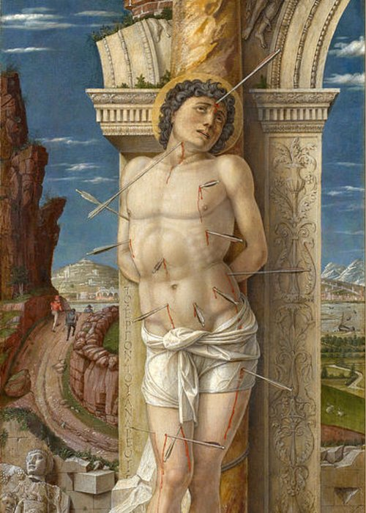
St. Sebastian
This week we celebrate the well known St. Sebastian, patron saint of athletes, archers, and invoked against plagues (since the pagans thought plagues were sent via poison arrows from the gods). Many young men choose St. Sebastian as a model for their athletics. However, many people are unaware of the full story of St. Sebastian. Sebastian was born in the Roman Empire in 256. He entered the army in order to covertly assist the Christians being martyred in the persecutions. His skill and virtue led him to many honors, and he was appointed to the “secret service” unit to guard the emperor Diocletian. St. Sebastian was great at concealing his faith, yet living it boldly. He ministered to many Christians and converted many pagans. He even converted the prefect and his family, and another time converted a jailer and all his prisoners who then were set free. Sebastian eventually was caught as being a Christian at the age of 32, and Diocletian condemned him to death for “betraying” him, even though Sebastian guarded the emperor with his life for years. Sebastian was tied to a stake and used for archery target practice. The archers shot at him until “he was as full of arrows as an urchin is full of pricks,” and then left him for dead. However, miraculously he did not die. A widow of a Christian guard previously martyred by Diocletian, St. Irene of Rome, came to bury his body, but realized incredible that he was still alive, took him in, removed all the arrows, and nursed him back to health. After Sebastian made a full recovery, he set out to rebuke the emperor for his actions. He stood by as Diocletian passed and admonished him for his treatment of Christians. Diocletian was astonished to see a man who supposedly was dead reproaching him so openly, and was shocked. When he recovered his senses, rage overtook him and he ordered Sebastian be beaten to death and his body thrown into the sewer. Sebastian did die this time and appeared to a woman named Lucina in a vision to recover his body. She did, and his relics are revered to this day. The top of his skull is encased in silver and was used as a chalice for the Blood of Christ on St. Sebastian’s feast day. Sebastian was courageous, charitable, and uncompromising. He entered his profession to help Christians that were being killed, knowing all along the risk he was taking. He also pursued excellence in all things. Even though his main goal was to help Christians, he also gave his best as a soldier and ended up in the elite forces. Finally, he didn’t let fear of death deter him from preaching the Gospel, and even went back to his murderer for a second round. Can you imagine going through the pains of almost death from arrows, the pains of removing all the arrows, and then returning for definite death from being bludgeoned? Imagine the look on Diocletian’s face as he believes he is seeing the ghost of Sebastian, only to realize he really is alive. And let us not forget the bravery and charity of St. Irene who came to bury his body and nursed him back to health, and Lucina who fished his body out of the sewer to bury him. Both risked being discovered as Christians and killed themselves. Being Christian in our world does not involved risking your life. Let us not take our faith or freedom for granted! St. Sebastian, invoked against plagues, pray for us and an end to COVID!

