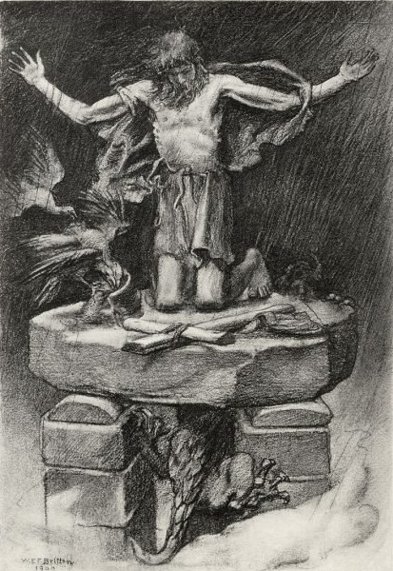
St. Simeon the Stylite
St. Simeon was born a to a shepherd family in modern day Turkey. When he was 13, he heard a reading of the Beatitudes which changed his life. He entered a monastery at age 16, but was too intense in his penances to stay. He thus became a hermit living in various places. After spending one entire Lent without eating or drinking, which was considered a miracle, he developed a following. He kept seeking solitude, but pilgrims kept coming to see the holy monk. In desperation for solitude, he discovered a 10 foot pillar in a nearby town in Syria. He climbed atop and lived there for the next few years. People would bring food and water to him in a pulley system, but he lived very austerely and completely exposed to the elements. He prayed all day and would assume various prayer poses throughout they day. Some other monks heard about him and wanted to test his sincerity. So, they came and ordered Simeon down. He obeyed humbly, so they decided he was sincere and let him go back to his pillar. Later, he moved to a 50 foot pillar to gain more solitude. His pillar was just over 3 square feet. From here he continued to live, never again coming down. People started following his example and more men became stylites. Simeon also received people twice a day to preach, settle disputes, and give advice. He also wrote letters to powerful people of the day. He always was cautioning against profanity and usury, but was also full of compassion, temperance, and common sense. He lived an intense life of austere penances in retribution for the sins of the world, but didn’t ask others to do the same. He knew this was his path to holiness, and encouraged others to find God’s will for their own life. One spectator watched Simeon while he was praying. He saw Simeon bow, bending his forehead to his feet, 12,044 times before he gave up counting. Simeon eventually developed an ulcer in his thigh, probably cancerous. After 37 years on top of his pillar, his disciples found his body stooped over in prayer. He was buried close to his pillar, and a Church was built over his grave. Unfortunately his pillar and Church, located close to Aleppo, Syria, were destroyed by a missile in the Syrian civil war in 2016. We have much to learn from St. Simeon the Stylite, especially in regards to penance and prayer. Simeon went to extremes to seek out silence for prayer. Do we even think about taking silent time to pray? Or do we run away from silence and run to distractions? In regards to penance, the Catholic Church requires all those from age 18-59 to practice some sort of penance on every Friday of the year. Traditionally it has been fasting from meat, and the Church still requires that in Lent. However, it must be some sort of penance on every Friday unless it is a Solemnity. So, do we embrace any form of penance? Do we fast and pray for the sins of the world? St. Simeon Stylite, pray for us!

