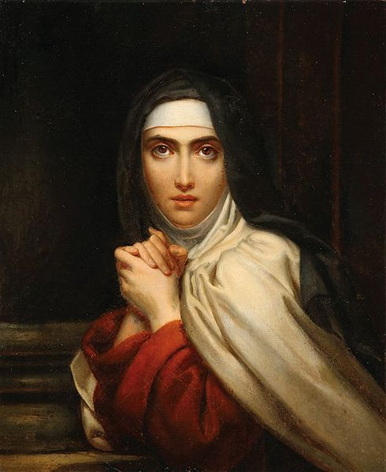
St. Teresa of Avila
This week we celebrate St. Teresa of Avila. Teresa was born in Spain in 1515 to an affluent family. Early on, she was a pious girl who tried to run away to Africa to be a martyr with her brother. However, as she grew she devoted more attention to worldly desires. She had a fireball personality, and was always the life of the party. She was also very stubborn and energetic. She eventually decided to join an easy-going Carmelite convent and greatly indulged in the socialite atmosphere there. She entertained many guests in the convent parlor. During this time, she also had an experience where God offered her great gifts of prayer, even unitive prayer where she would be one with Christ. However, she rejected all these gifts and chose instead to live the worldly life. It wasn’t until later that she came to her senses and realized the goal of life is union with God, aka heaven, not social status. So she characteristically went through a complete turn-around and devoted herself intensely to the spiritual life. She finally accepted God’s gift of intense prayer and started having mystical experiences and levitating. An angel came and pierced her heart with a flaming spear, setting her heart afire with love of God. She also believed her Carmelite convent was too lax and started a movement toward much stricter fasting, silence, prayer, and penance. This was met with much opposition, and her stubbornness helped her endure such persecution. Frustrated by rejection, she once told God, “If this is how you treat your friends, no wonder you have so few of them!” As St. Teresa continued growing closer to God and leading others closer to him too, she realized her main point had to be prayer, particularly mental prayer. She wrote her book The Interior Castle describing how the soul gradually unites with God in prayer like a person walking into a castle. You start at the doorstep and eventually move to the deepest chamber. For all her work and writings, St. Teresa of Avila was the first woman, along with St. Catherine of Sienna, to be named a Doctor of the Church. In imitation of St. Teresa of Avila, let us strive to use our unique gifts and talents for the greater glory of God! Let us also devote ourselves to mental prayer.
St. Alphonsus Liguori gives a simple three step process to mental prayer. First, prepare yourself by telling God you believe in Him, love Him, and are sorry for having hurt Him with your sins. Ask for whatever grace you desire from your prayer time. Second, read a meditation, stopping and talking to God whenever anything stands out. As St. Francis DeSales says, you can be like a bee that settles on a flower as long as there is nectar, then moves along. Scripture or a prayer book are the best places to start with meditations. Finally, conclude by making a resolution and thanking God for the time of prayer with an Our Father.
We can also learn from St. Teresa of Avila that saints come in all shapes, sizes, and personalities. She was always lively and had a great sense of humor. Forceful and stubborn, she also had faults to overcome, but could use her personality and popularity for God. The one big lesson we have to learn from St. Teresa is prayer is what changes us. If we don’t allow God to work, he will not force His will. God offered himself to Teresa, but she refused. It wasn’t until she opened herself up to Him in prayer that she became a great saint! St. Teresa of Avila, pray for us!

