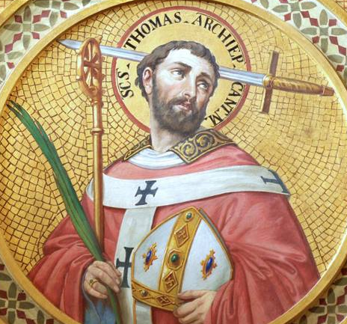
St. Thomas Becket the Daredevil
This week is full of celebrations! We continue to celebrate the Octave of Christmas, the Holy Family, Mary the Mother of God, and the Holy Innocents! This week we also celebrate some great saints! St. Thomas Becket was one of these. Born in England in the 1100s, Thomas was smart, popular, and a sportsman. He was well-built, spirited, athletic, and an avid hunter and outdoorsman. Being a daredevil by nature, he was known to be risky, daring, and adventurous. He pursued the high society hunting and falconry life, and once dived into a raging river to save a valuable hawk. Through these escapades, he became great friends with the young prince Henry II. Thomas also had a spiritual side though, and began pursuing a vocation and career in the Church. He was charismatic, bold, stubborn, and lovable, yet also wise and discerning. When Henry II became king, he recognized his friend’s talents and wanted a close friend in the Church to be on his side, so he made Thomas a chancellor. Thomas even rode into battle with Henry. Later, King Henry II gave Thomas the highest seat of the Church in the country of England and made him Archbishop of Canterbury before Thomas was even ordained a priest. So Thomas was ordained a priest one day and consecrated a bishop the next! Thomas rode along with these favors, but they exposed drastic problems the king had with the Church. The king had way too much power over the Church in England, appointing offices and such, and was bent on gaining more. Thomas loved his friend and was loyal to him, but was loyal to God and the Church first, so he knew trouble was brewing. Thomas even asked the king to not make him Archbishop of Canterbury because it would put stress on their friendship, but the king didn’t believe Thomas would side with the Church over him. Thomas even raised and tutored King Henry II’s son, so close was their friendship. But at this time, Thomas knew he must prepare to stand up for his faith. He left the worldly high society behind and began wearing hairshirts, doing penance, giving alms, and devoting more time to prayer. Things were fine for many years, but tensions began to mount when the King attempted to flex his power over the Church. Many different situations developed, and Thomas dared to stand strong against the king’s errors over and over again. Thomas was still a loyal friend, but had to give priority to obeying God, the Church, and the Pope over his best friend and king. The breaking point occurred when Thomas excommunicated two bishops. The king was not happy and ordered Thomas to revoke the excommunication or face his judgement. Thomas said he could not revoke it and was not under the king’s judgement authority in that regard. The king became enraged and made a passing comment about who would rid him of this pesky priest. Four of his knights heard this and in a frenzy set off to kill Thomas. Thomas was warned, but refused to leave his cathedral and headed to the church for vespers. Other monks tried to bolt the doors, accidentally locking their brother monks out, but Thomas cried this is a cathedral, not a castle and refused to lock the doors to God’s house. The knights eventually poured in crying “Where is Thomas Becket, traitor to the king and country?!” Thomas, bold as ever, said, “Here I am...I am no traitor and am ready to die.” Thomas even rebuked the knights telling them they owe obedience to him as Archbishop. The knights tried to drag Thomas outside, but Thomas held on to a pillar and bowed his head in prayer. The knights struck his head multiple times, one even breaking his sword over his head. It took over four strikes to the head for Thomas to collapse on the ground, and the knights spewed his blood and brains across the floor. He was 50 when he was martyred. When King Henry II heard of Thomas’ death, he shut himself up, fasted for 40 days, and performed public penance. He had not intended his words to mean the death of his friend. Later he received absolution. After just three years, Thomas was canonized a martyr and saint. Even though Thomas had his own faults and sins, when the time came he was willing to die for Christ and His Church. St. Thomas Becket, pray for us!

