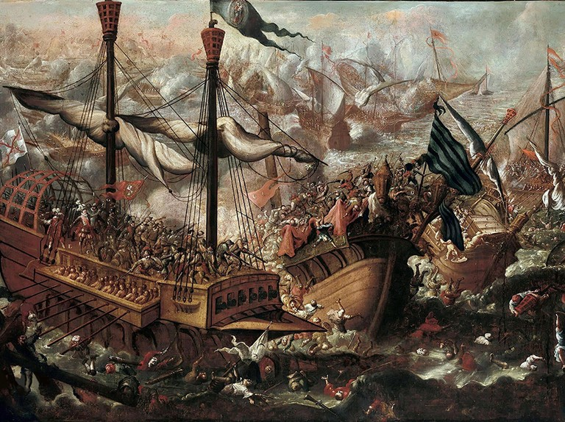
The Battle of Lepanto
This week we celebrate Our Lady of the Rosary. The history of this feast dates back to the Battle of Lepanto in 1571, one of the most significant naval battles in all of history. To place the battle in context, let’s look at the state of Europe at the time. The Protestant Reformation started in 1517 and was in full swing with violent wars frequently happening. It ripped apart much of the unity of the nations in Europe and destabilized many monarchies. Furthermore, Muslim invaders were knocking at the door, ready to conquer all of Europe. Since the 1200s, Muslim raiders harassed much of Italy, Spain, and Eastern Europe, looting and taking captives for ransom or to be used as slaves. Europeans were terrified of Muslim invasion for multiple reasons. Firstly, the Muslim Ottoman empire was Muslim and based on religion. Christianity may have been tolerated, but was brought about class restrictions and persecution. Secondly, the Muslim Ottomans frequently took Christians captive to use as slaves or ransom. This was so common that an entire religious order, the Mercedarians, was founded in the 1200s to raise money to ransom Christians. Many Mercedarians were martyred when they ransomed themselves for the captive Christians. Finally, the Sultan, Suleiman the Magnificent, was far from the ideal ruler of Christian Europe. Besides his political desires of conquering and expanding his empire, he lived a life quite opposite of the Christian life. He executed two of his sons out of fear of rebellion, had 17 wives, and had a favorite wife who was the daughter of an Orthodox priest who had been kidnapped and sold as a slave. His generals also went back on their word and gorily killed some Italians they promised safety to. All considered, Christian Europe was terrified of an Ottoman takeover, and in 1571, it seemed imminent. As the Ottomans drew near, Pope St. Pius V organized an alliance of Italian nations and Spain called the Holy League to fight back. He also encouraged all the faithful to pray the rosary for a miraculous win to the eminent battle. During the battle on October 7, 1571, the wind turned at the last minute in favor of the Holy League and a long battle ensued. This was the last major naval battle using rowing vessels. Total, there were over 400 ships. As the ships crashed into each other, it turned into a hand to hand melee. As the Holy League gained the upper hand, all the Christians slaves on the Ottoman ships who were used as rowers were freed and joined combat against the Ottomans. All together, 12,000 Christian slaves were freed, 40,000 Ottomans were killed and 10,000 Christians were killed. As the battle finished, Pope St. Pius V miraculously knew it was over, even though he was in Rome. The battle was a huge victory for Christian Europe as the Ottoman empire was never feared again. For the Ottomans, it was the beginning of the decline of the empire. Pope St. Pius V declared October 7 the feast of Our Lady of Victory, attributing the victory to her intercession. Later, the feast was changed to Our Lady of the Rosary, as the Rosary was the secret weapon that ensured victory. Let us also remember the Rosary as our secret weapon against all the battles of our day. St. Josemaria Escriva said, “The holy Rosary is a powerful weapon. Use it with confidence and you’ll be amazed at the results.” Our Lady of the Rosary, pray for us!

