The Nativity of Our Lord
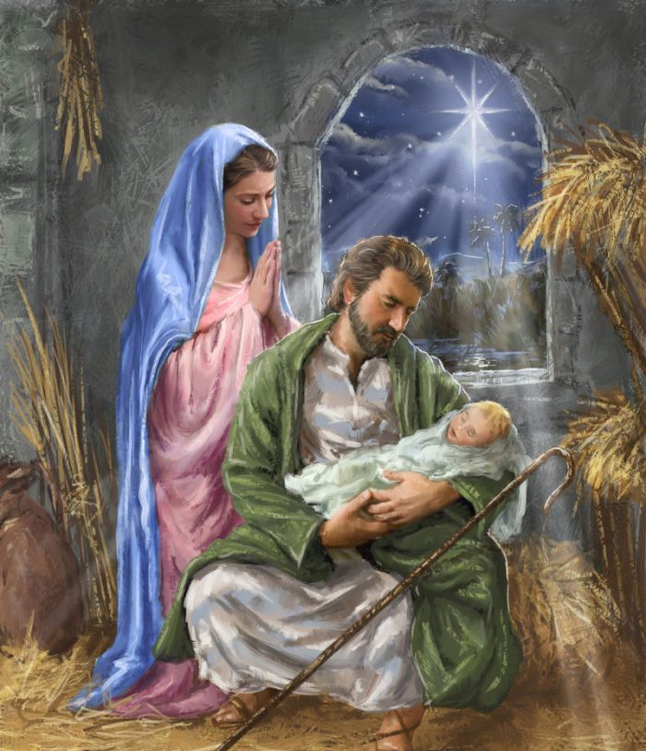
This week we celebrate the great occasion of The Nativity of Our Lord! Merry Christmas! However, for many years, Christians never celebrated the birth of Christ. Why? Well all the worldly people always celebrated the birth of their kings, emperors, and heroes, and most people celebrated their birthdays because everyone is born. Yet Jesus is so different because he not only was born and died like everyone in all of history. Jesus was so different because He is the only man ever to raise Himself from the dead! So clearly the thing to celebrate is the Resurrection, and that is why Easter was and still is the largest celebration of the Church! The pagans of the time also used Jesus’ birth as proof that Christianity was a farce. They argued that no God in his right mind would ever, ever enter the realm of humans and lower himself or his son to such a low level of being born a human. Not to mention being born poor in a stable with filthy animals. So it was reasonable that Christians didn’t celebrate Jesus’ lowly birth. His Resurrection was the main point of Christianity anyway. His Resurrection proved He was God and had the power of God. However, Christians soon realized we needed to celebrate Jesus’ birth because it proved something incredible. It didn’t prove God’s power, but it proved God’s love. The Nativity proves God’s untiring, impossibly merciful, passionate love for us! How does the Nativity prove this? Most religions are all about man’s pursuit of God. Some Christians mistakenly think this of Christianity as well. But Christianity is about God’s pursuit of man. God does not wait for us to figure things out and fix ourselves. He bursts into our filthy, stinking, sinful world, and lives, as the light of the world, our one true lover, our creator, our redeemer, our savior. Besides the animals, lowly grungy shepherds were his first adorers. The bread of angels, our spiritual nourishment, He who would later say, “unless you eat my flesh and drink my blood, you have no life within you” and gave His body, blood, soul, and divinity for our life, was laid in a manger, the feeding trough of the animals. Jesus, who became the Eucharist, was born in the town called Bethlehem, or “House of Bread.” He was born as a poor helpless baby, completely approachable. In every way, God entered this world in the flesh to pursue us, to draw us to Him, to prove His unstoppable love for us! And He left us His body, blood, soul, and divinity in the flesh to continue that pursuit. He wants to be our light, our savior, our lover. Venerable Fulton Sheen next begs the question, what does it matter that Jesus was born into this world if he isn’t born into your heart? God made man, Jesus, is pursuing us. But the question is will you receive His pursuits? God is lowering Himself to the lowest level possible, will you accept His advances? God is coming to Earth every day also physically in the Eucharist! Will you receive Him as much as possible through Holy Communion or a spiritual communion? God is bending over backward to try to win over our love and affection, and to prove His love for us. That is why Christians decided to celebrate the Nativity of Our Lord. Christmas is a scandal to most other religions because they can not understand God loving each individual so much, but that is the Truth of Christianity! Let us celebrate this truth well this season! May we always receive God’s love in our lives. May Jesus be born into our hearts this Christmas, and everyday of our lives! Mary and Joseph, pray for us to receive Jesus in our hearts today and everyday!

