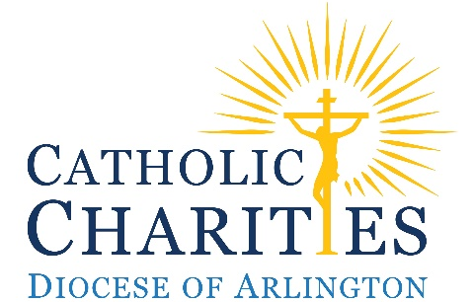
Annual Parish Christmas Collection
Manual

December 5 and 6, 2020 – Special Talks
December 12 and 13, 2020 – Collection

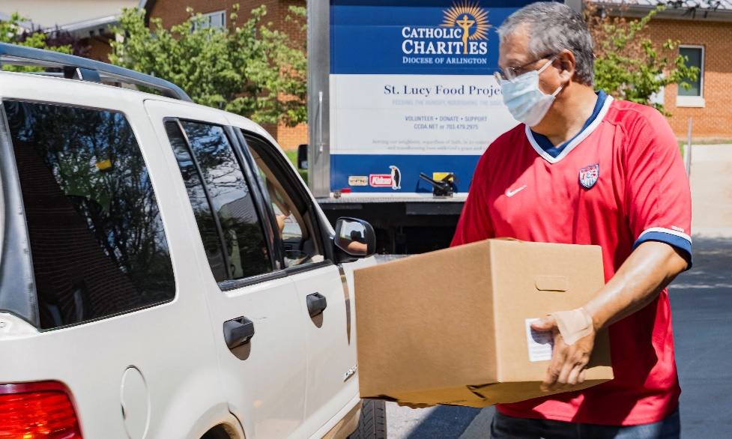
By the Grace of God

Catholic Charities of the Diocese of Arlington
200 North Glebe Road, Suite 250 | Arlington, Virginia 22203 | 703-841-3841 | ccda.net
Thank you for your continual support of the most needy in our diocese. This Second Collection provides an opportunity for parishioners to play an additional role in helping those we serve. By making a gift, they are responding to the call to live out their faith by supporting their brothers and sisters in distress throughout our diocese. This effort updates them on the work of Catholic Charities and asks for their prayerful consideration of supporting our work at the end of the year. Catholic Charities is an apostolate of carrying out the love and service that Christ calls us to bring to the poor. We prayerfully ask for your support.

The annual Catholic Charities Parish Christmas Collection provides 9% of the annual fundraising revenue in one weekend. While the Bishop’s Lenten Appeal provides critical support, this collection and other fundraising are very necessary to allow Catholic Charities to carry out its mission to serve those in need.
CONTENT AND ADDITIONAL RESOURCES

In this manual you will find:
- Important dates for planning
- Suggested bulletin announcements
- Talking points and suggested scripts for December 5 – 6 and December 12 –13
- Helpful contact information

On our website: ccda.net/ChristmasCollectionParishResources you will find additional resources:
- The Parish Manual
- Lay Speaker - Talking points
- Christmas Collection flyer
    - A PDF version that you can share electronically
- Social Media
    - Images that can be shared in an email or via social media
- Emails
    - Email Template to promote the Collection to parishioners

Important Dates for Planning

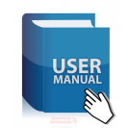
Week of November 23, 2020
Parish Informational Materials, Manual, and Bulletin Insert delivered to all parishes.

1st Parish Bulletin Announcement appears encouraging participation in the upcoming Annual Parish Christmas Collection for Catholic Charities.

Weekend of December 5 and 6, 2020 – Testimonial Weekend
Special Bulletin Insert Flyer/ Contribution Envelope included in all parish bulletins.

2nd Parish Bulletin Announcement appears encouraging participation in next weekend’s Annual Parish Christmas Collection for Catholic Charities.

Annual Parish Christmas Collection Testimonial Speaker or Pastor / Priest offer brief remarks at all Masses. Bishop Burbidge asks all parishes to have a special announcement given in support of the Annual Parish Christmas Collection. If a lay speaker presents, it is recommended that the Pastor/Priest briefly endorse the collection at the beginning or end of their remarks.

Weekend of December 12 and 13, 2020 – Annual Christmas Collection Weekend!
3rd Parish Bulletin Announcement appears encouraging participation in the Annual Parish Christmas Collection for Catholic Charities at all Masses on this day. Some parishioners may have forgotten their checkbooks or envelope, so please encourage them to contribute online and take a Bulletin Insert which includes the online giving information.

Suggested brief Pulpit announcement made about the critical value of participating in the corporeal works of mercy in the Annual Parish Christmas Collection for Catholic Charities in the diocese’s ability to serve the poor.

Weekend of December 19 and 20, 2020 – Weekend of Gratitude!
4th Parish Bulletin Announcement appears thanking parishioners for their participation in the Annual Parish Christmas Collection for Catholic Charities and encouraging those who have not given to discern a gift.

2020 PARISH BULLETIN ANNOUNCEMENT SUGGESTED MESSAGES
Bishop Burbidge asks all parishes include announcements in support for the Catholic Charities Annual Parish Christmas Collection in their parish bulletin. Please edit the bulletin announcements below if needed.

November 28 and 29, 2020 – Preparing the Way Weekend
2020 Annual Parish Christmas Collection for Catholic Charities is Coming Up!
Your Generosity is Deeply Appreciated.

2020 has been a challenging year for many of us and our neighbors, so we ask that you consider making a special gift to support the needy and disenfranchised throughout our diocese by supporting Catholic Charities of the Diocese of Arlington’s programs. This allows you to play a direct role in spreading the love of Christ for the poor. Look for a special insert in the parish bulletin at Mass next weekend. If donating with check, please note Catholic Charities on the memo line or make a gift online at www.ccda.net/donate/ChristmasCollection.
December 5 and 6, 2020 – Testimonial Weekend
Thousands of men, women and families are served annually by Catholic Charities.

Catholic Charities shows the transformative love of Christ and serves tens of thousands of men, women and families in dire need annually through more than 21 programs across 21 counties and 7 cities that make up the boundaries of our Catholic Diocese of Arlington. Please take advantage of this opportunity for now, more than ever, you support is needed. Use the special bulletin insert/contribution envelope provided or go online to www.ccda.net/donate/ChristmasCollection to share a gift from your blessings.
December 12 and 13, 2020 – Annual Parish Christmas Collection Weekend
Please give to the 2020 Annual Parish Christmas Collection for Catholic Charities.

Today is the annual Parish Christmas Collection for Catholic Charities of the Diocese of Arlington. Their personal mission is to serve the poor with Christ’s love and compassion – and your support of this collection is vital. Please prayerfully consider supporting those cared for across our large diocese. If you are not able to make a gift today, please make a gift in next week’s collection and note Catholic Charities on the memo line of your check or visit www.ccda.net/donate/ChristmasCollection.
December 19 and 20, 2020 – Weekend of Gratitude
Your Gifts to Catholic Charities Are Deeply Appreciated!

Thank you for your generous support of Catholic Charities which is essential to their work. Those who will benefit are so grateful for your gifts. If you missed the collection, you may still make a year-end gift by going online at: www.ccda.net/donate/ChristmasCollection.
December 5 and 6 - PULPIT TALK
(Please keep to 2-3 minutes)

Thank you for offering to speak on behalf of the parish Christmas Collection this year. Below you will find a summary of important points to cover, as well as draft text that you can modify and use in your remarks.

Topics to Cover
- Announce that the Christmas Collection will occur next weekend
- Describe the work of Catholic Charities that this collection is critical to supporting
- Share client service statistics (see below)
- Mention relevant Catholic Charities activities at your parish
- Highlight suggested gift amounts and their respective impact
- Share client quotes
- End with thanks!

Draft Text for Remarks (including client-service statistics and client quotes)

“The Annual Parish Christmas Collection for Catholic Charities will take place next week at all Masses. Thank you for the opportunity to talk briefly about the impact of our Catholic Charities to help you understand the importance of their work.
Catholic Charities works in partnership with our parish ministries to help those most in need. But Catholic Charities also brings Christ’s love to some grave, important issues that are more than any one parish can handle
- Housing homeless families with little children and expectant mothers;
- Bringing food and critical supplies to food pantries and parishes in our poor rural counties;
- Adoption and supportive services for birth families and birth mothers;
- Free medical clinics including pre-natal care for those with no health insurance;
- Professional Catholic counseling services to anyone anywhere in our diocese;
A gift to Catholic Charities supports these critical works of mercy throughout the 21 counties in our diocese. Now, more than ever, your help is needed.
This past year your support has had a tremendous impact on those suffering through the work of Catholic Charities. Allow me to give you a few examples:

- Hunger is the biggest casualty from the pandemic. Catholic Charities distributed 1.3 million pounds of food to the hungry through their The St. Lucy Food Project
- Serving 15,228 free hot meals every single night to hungry families and individuals at Christ House
- Providing 3,968 clients with emergency assistance funds to avoid homelessness and/or loss of their utilities. (Think about that: nearly 4,000 families in our diocese!) That includes 47 women and children, and 23 men that have transitioned from homelessness to sustainable housing
- Treating 1,140 uninsured patients with free medical care at the Mother of Mercy Free Medical Clinic
All donations stay in our diocese and our independent auditors confirm that 85 cents of every dollar spent goes directly to serving the poor.
Please know that your donation will have an immediate impact for those in need:
- $500 will help prevent homelessness by helping a family living paycheck-to-paycheck pay their rent and avoid eviction.
- $100 will keep the heat and the lights on in a family’s home for two weeks.
- $50 will feed a family of three for one week.
Your donation is greatly appreciated by all those served by Catholic Charities and I thought I would share a few quotes which illustrate just how transformative your gifts are in their lives
Quote from a mother who lived with her two children at St. Margaret of Cortona Transitional Housing for Families
“Catholic Charities helped me save my money, learn new budgeting skills, and provided me with therapy. They helped me gain my independence again and gave me hope.”

Quote from a client who received counseling services from Catholic Charities
“I’m finally able to be the father my children deserve,” said a father who was struggling with depression and suicidal thoughts. He could not keep a job and was losing his relationship with his children. “I’m not sure where I’d be today if I hadn’t come to Catholic Charities for help. I think this place saved my life.”

Quote from a client of Hogar Immigrant Services – Legal, MRS, and Education Workforce and Development, who won her asylum case in immigration court
“Preparing for the hearing was very stressful. Sometimes I forget that my immigration process is over. It feels like a dream. I thank God that so many doors are open to me now. God is good and forever God is good.”

Thank you for listening and please prayerfully consider partnering with us to love and serve the poor and allowing us to transform lives by joining and supporting this impactful work in the collection next week. I’ll be in the back and I am happy to answer any questions. God bless you and thank you for your time.”
December 12 and13 – PULPIT ANNOUNCEMENT- Pastor/Priest
“Today, we are happy to be taking up the Annual Parish Christmas Collection for Catholic Charities – charged with carrying out the Corporal Works of Mercy throughout our diocese. These are important and much needed works. This collection provides ~10% of their annual budget. The needs are greater than the Bishop’s Lenten Appeal can support. Can you make this important Christmas gift to the poor today?
So please prayerfully consider a gift to our own Catholic Charities as a Christmas gift to the poor. Your gift can bring the love of Christ to the farthest reaches of our diocese and show how the Church is committed to helping all people regardless of their faith. Thank you for your generosity.”
___________________________________________________________________________________
For any comments or questions about the Parish Christmas Collection, please contact:

MEAGHAN DOFFLEMEYER
Staff Liaison to Parishes for Parish Christmas Collection
Associate Director, Catholic Charities Annual Fund Programs & Development Services
Catholic Charities
703-841-3841
meaghan.dofflemeyer@ccda.net

ART BENNETT
President and CEO
Catholic Charities
703-967-4157
arthur.bennett@ccda.net

JEFF ROSTAND
Vice President and CFO
Catholic Charities
703-841-3899
jeffrey.rostand@ccda.net

