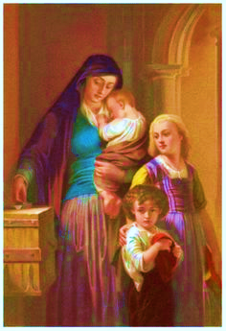
WIDOW’S MITE SOCIETY
OUR MISSION IS TO HELP THE WIDOW/ER WITH THE GRACE
OF GOD TO THE BEST OF OUR ABILITY AT THE SAME TIME
BRINGING TOGETHER OUR COMMUNITY TO EXPERIENCE
THE JOY AND SPIRITUAL LOVE OF SACRIFICAL GIVING.

Render service with enthusiasm, as to the Lord and not to men and
women, Ephesians 6:7

We offer services to our community’s widow/ers who cannot manage small household tasks, such as maintenace, minor household repairs, and house cleaning. Once a month we will go to a parishioners house on a Saturday morning for three hours and do whatever they need. If there is a task that requires expertise that we can not give we have individuals who can help assess the situation and make proper referrals to help get the project finished.

Our services include painting, fence repair, limited plumbing, heating and cooling maintenance,
Mowing lawns, weed removal, trimming small trees and bushes, trash removal, vacuuming, dusting, sweeping and mopping, organize small areas, and companionship while offering our services in your home.

At present, the Widows Mite Society is limited to helping out in 10 homes a year. Donations are welcome of time or treasure. If you are interested in donating or joining the Widows Mite Society, please contact the Parish Office or come to our meetings on the 4th Tuesday of each month at 6:30pm at the Faith Formation Center.

IF YOU ARE A WIDOW/ER IN NEED OF HELP PLEASE FILL OUT THE BOTTOM OF THE FORM AND BRING IT TO THE OFFICE OR DROP IT IN THE COLLECTION BASKET.
……………………………………………………………………………………………………..
HOW CAN WE HELP
NAME______________________ ____mowing lawns
PHONE_____________________ ____weed removal
Do you_____own or _____rent? ____trimming small trees and bushes
Address_____________________ ____trash removal
____________________________ ____vacuuming
Please check all that apply ____dusting
___painting ____sweeping and mopping
___fence repair ____organize small areas
___limited plumbing ____companionship while offering our
___heating and cooling maintenace services in your home
____other, please specify
_______________________________

