Dear Sisters and Brothers,

Two items for my letter this weekend: a note from our parish St. Vincent de Paul Society and some information about another outreach program in our parish. First, from St. Vincent de Paul:

The Holy Family Parish St. Vincent de Paul Society THANKS YOU!
THANK YOU for your generosity in supporting our mission of helping those in need in our parish and elsewhere in the town of Concord. In the past year we processed 83 requests for aid and assisted 37 Concord families and 6 homeless people - all through your help! We assist these folks in resolving their short-term financial crises for shelter, transportation, food, healthcare, and other emergency needs. We have also delivered complete meals directly to the homes of approximately 50 Concord families for each of the Thanksgiving, Christmas, and Easter holidays. We have raised and disbursed over $33,000 in 2017 to aid our neighbors. Through our work, we are continually reminded that, even in our affluent town, there is poverty that calls out to us as Catholic Christians to come to the assistance of those most in need.
We appreciate your support and encourage you to help us further our work either as a volunteer and/or through your financial contributions. You can contact us by dialing the Holy Family Parish phone line 978-369-7442 (the SVdP extension is 229) or by mail at St. Vincent de Paul Society, c/o Holy Family Parish, P.O. Box 220, Concord, MA 01742 or by email at SVDP@HolyFamilyConcord.org
Financial contributions can be deposited in the St. Vincent de Paul boxes at the two entrances to the church or sent to St. Vincent de Paul Society at the parish mailing address: Holy Family Parish P.O. Box 220 Concord, MA 01742.

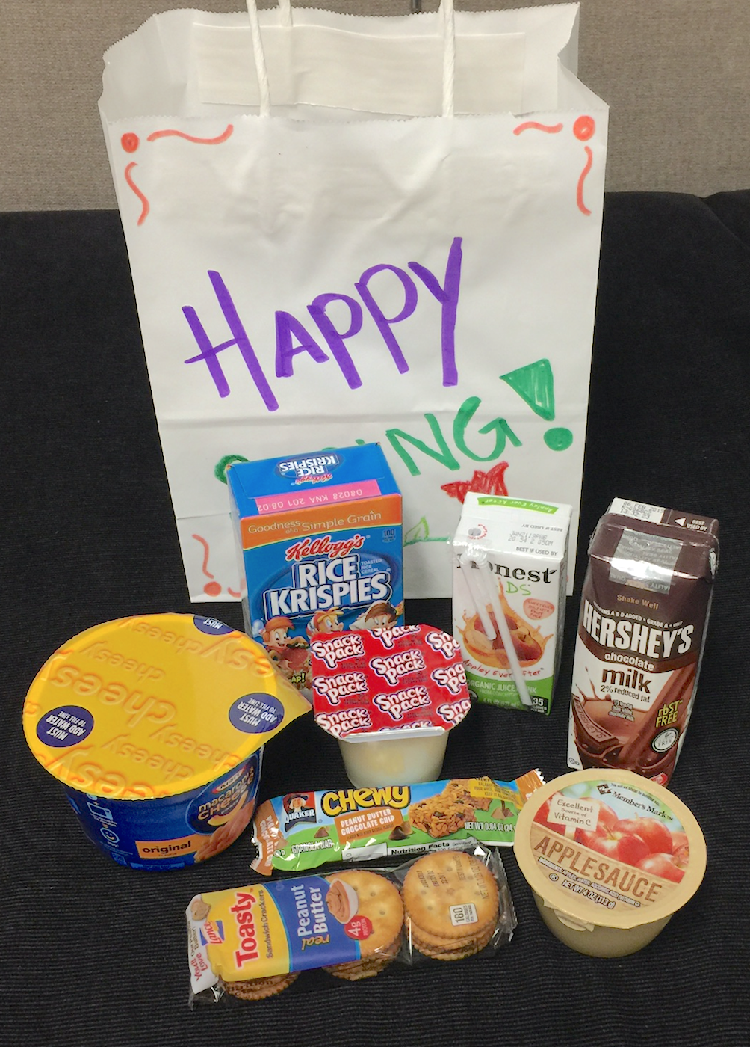
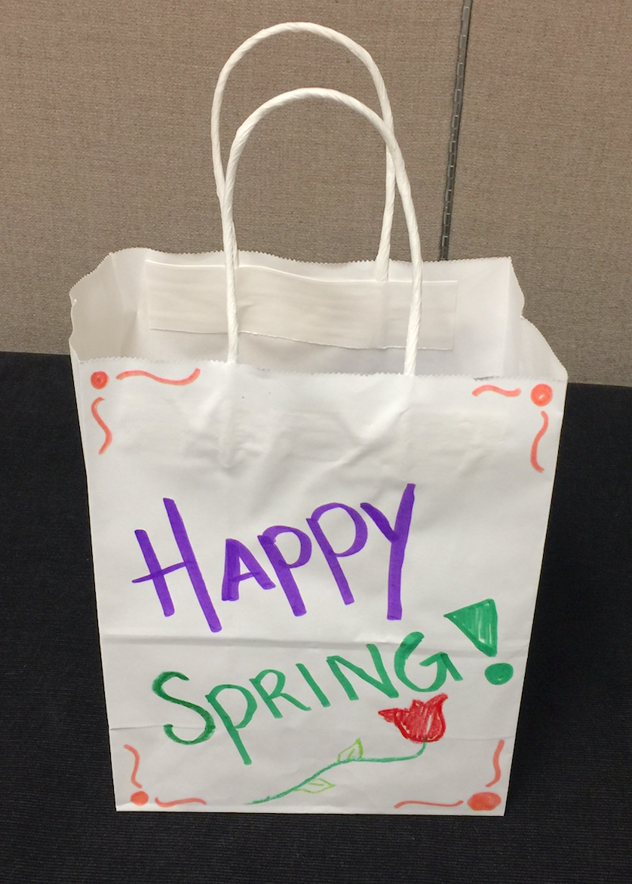
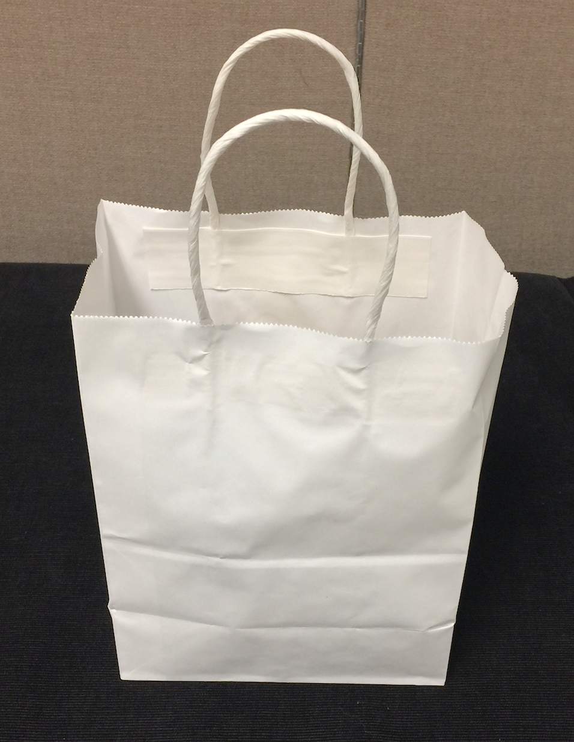
You sometimes hear me announce at Mass an opportunity to decorate and fill “Open Table Bags for Children.” Open Table serves families in need of food in Concord and surrounding towns. In addition to providing a meal at a central location, groceries are also distributed. Families with children come for food and so in addition to a bag of groceries, children are offered a “kid’s bag.” These begin as plain white bags which our young people decorate and then fill with snacks - as these photos illustrate. Just wanted to let you know abo ut a wonderful w ay our p arish reaches out to those in need!

