Tips for Choosing a Bible
Did you know….
- Books of the Bible written by various authors but all inspired by the Holy Spirit
- All books containing true Catholic doxology have a stamp of approval by Catholic Church
      - Look for Nihil Obstat and/or Imprimatur on the back of the title page
- Catholic Bibles contain seven more Old Testament books than Protestant Bibles
- During the Reformation, Protestants removed seven books that had been part of the Bible since the beginning of Church history

Here are a few Bible examples that might help 😊
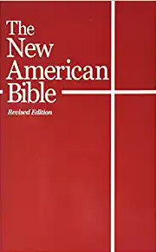 | The New American Bible  - Easy to understand  - Modern translation  - Easy use for all ages | 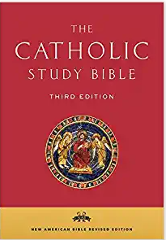 | The Catholic Study Bible 3rd Edition  - Extensive reading guide  - Book-by-book through Scripture  - For higher education and general readers
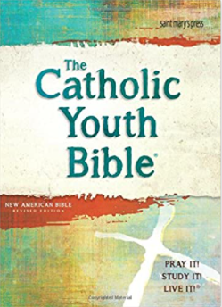 | The Catholic Youth Bible 4th Edition  - Full-color design  - Easy-to-use Navigation  - Multiple opportunities for youth interaction with scriptures | 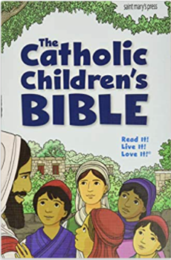 | The Catholic Children’s Bible  - Color-coded tabs easy navigation  - Simple graphics  - Child-friendly Bible; grades 1-4  - Vibrant, realistic illustrations, and fun, colorful graphics

Local Catholic Stores
Queen of Angels Catholic Store  11629 San Jose Blvd. Suite 3 Jacksonville, FL 32223  904-288-0062 | The Blue Mantle  81 San Marco Ave Saint Augustine, FL 32084  904-907-2985

Helpful Websites
https://www.comcenter.com/ | https://www.amazon.com/
https://www.usccb.org/ | https://www.usccb.org/bible/understanding-the-bible
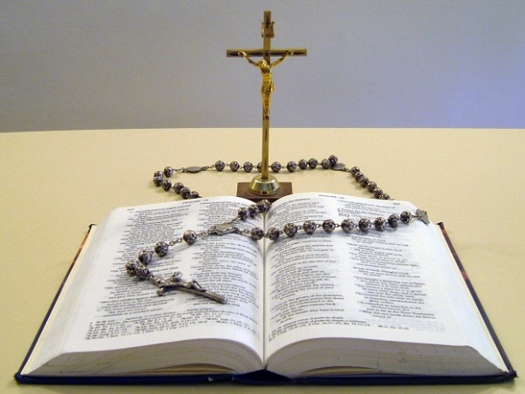
Making a Prayer Corner in Your Home

Why A Prayer Corner in Our Catholic Homes
- Good to SEE our Faith at home as well as HEAR at Mass
- Peaceful reminder of God’s presence
- God’s presence in our homes and lives 24/7

What Is a Prayer Corner
- Accessible area to gather as a family or individually
- Place you walk by and feel God’s presence
- Your own, personal, comforting, inviting place
- Silent testimony of your Faith in Our Blessed Mother, the Holy Family, our Lord Jesus Christ
- For more information see page 4 in the Parent’s Guide

Ideas of What You Can Include in Your Prayer Corner
- Crucifix for your prayer corner and visible in every bedroom of your home
- Bible (see examples within this document)
- Candle or a lighted candle on a timer that goes on every night
- Scripture quote, Saint quote, the 10 Commandments
- Statue, Picture, or Icon: Jesus, Mary, an Angel, a favorite Saint
  - Something that speaks to your family personally
- Holy water, family Rosaries
- Catholic books, picture books for kids, holy cards, prayer cards

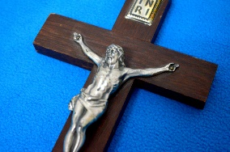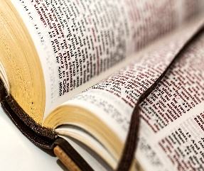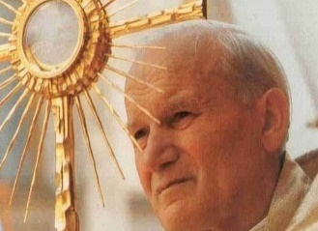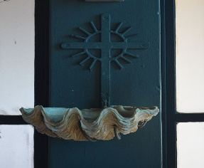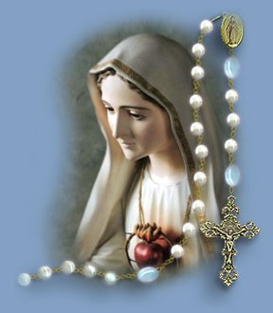
“Preach the Gospel always, and if necessary, use words”
St. Francis of Assisi

