September 2, 2019  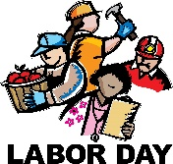  No School | September 3, 2019  Banana Bread Slice  Graham Crackers  Fruit Selection  Fruit Juice  Milk | September 4, 2019  Bagel w/Cream Cheese  Graham Crackers  Fruit Selection  Fruit Juice  Milk | September 5, 2019  Cinnamon Poptart  Graham Crackers  Fruit Selection  Fruit Juice  Milk | September 6, 2019  No School  Teacher In-Service
September 9, 2019  No School  Festival Clean Up | September 10, 2019  Trix Cereal Bar  String Cheese  Fruit Selection  Fruit Juice  Milk | September 11, 2019  Assorted Breakfast Cereal  String Cheese  Fruit Selection  Fruit Juice  Milk | September 12, 2019  Cinnamon Bread Slice  String Cheese  Fruit Selection  Fruit Juice  Milk | September 13, 2019  Chocolate Chip Muffin  String Cheese  Fruit Selection  Fruit Juice  Milk
September 16, 2019  Strawberry Poptart  Graham Crackers  Fruit Selection  Fruit Juice  Milk | September 17, 2019  Assorted Breakfast Cereal  Graham Crackers  Fruit Selection  Fruit Juice  Milk | September 18, 2019  Banana Bread Slice  Graham Crackers  Fruit Selection  Fruit Juice  Milk | September 19, 2019  Banana Muffin  Graham Crackers  Fruit Selection  Fruit Juice  Milk | September 20, 2019  Cinnamon Toast Crunch Cereal Bar  Graham Crackers  Fruit Selection  Fruit Juice  Milk
September 23, 2019  Apple Nutrigrain Bar  String Cheese  Fruit Selection  Fruit Juice  Milk | September 24, 2019  Banana Bread Slice  String Cheese  Fruit Selection  Fruit Juice  Milk | September 25, 2019  Assorted Breakfast Cereal  String Cheese  Fruit Selection  Fruit Juice  Milk | September 26, 2019  Cinnamon Poptart  String Cheese  Fruit Selection  Fruit Juice  Milk | September 27, 2019  Blueberry Muffin  String Cheese  Fruit Selection  Fruit Juice  Milk
September 30, 2019  Strawberry Poptart  Graham Crackers  Fruit Selection  Fruit Juice  Milk |  |  | Menu Subject to Change  Cost: $1.80  Reduced: $0.30 | 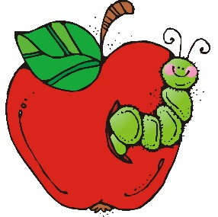

Student’s First and Last Name: ______________________________
Grade: ___________________
Number of Breakfasts ordered: _______________
Amount Enclosed: $_________________________

