How To Explain The 7 Sacraments Without Boring Your Children

Don’t know how to start explaining the seven sacraments of the Catholic Church to your son or daughter? Are you lacking material for your church’s catechesis program? Is it sometimes a bit complicated for you?
Don’t worry. Through this article, we’ll help you find the right words to help children understand these gifts of the faith.
The Sacraments are actions of God through which He shows us the love He has for us, His sons and daughters. All of the sacraments have been created (instituted) by Him, and that’s why it’s He who performs them through different means.
Why did He give the sacraments to us? To give us grace. That is to say, to give us, along with His love, the necessary strength to fight against and through the difficulties of life. Of course, that is, if we have a positive disposition and attitude that desires to please God.
What Are The Seven Sacraments Of The Catholic Church?

1. Baptism
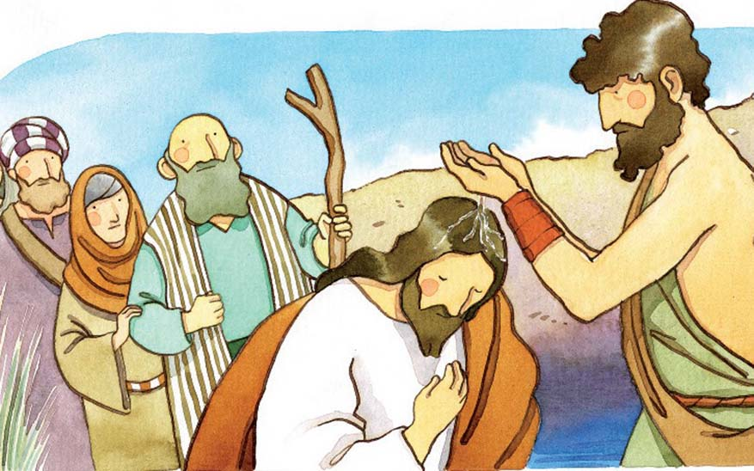
When we’re born, we all have something called original sin. It was the one first committed by Adam and Eve. When baptized, we are washed of that sin and of all those committed before receiving it. We’re made sons and daughters of God and we officially become a part of the Church.
God is very happy when the priest, while pouring holy water on the baptized one, says “I now baptize you in the name of the Father and of the Son and of the Holy Ghost.
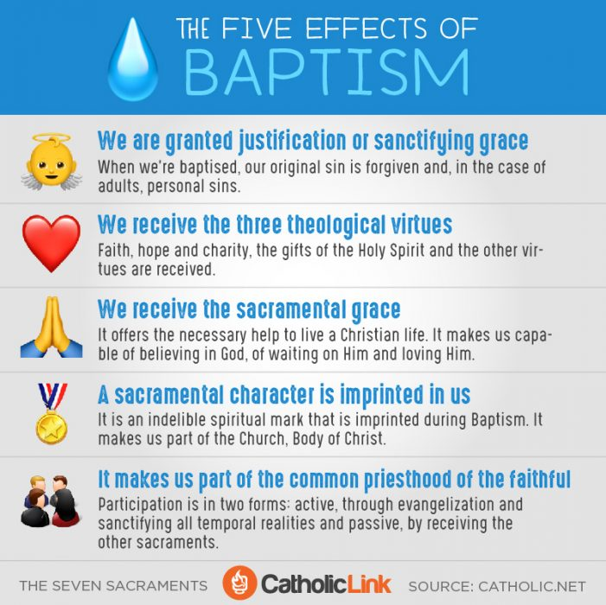

2. Confirmation
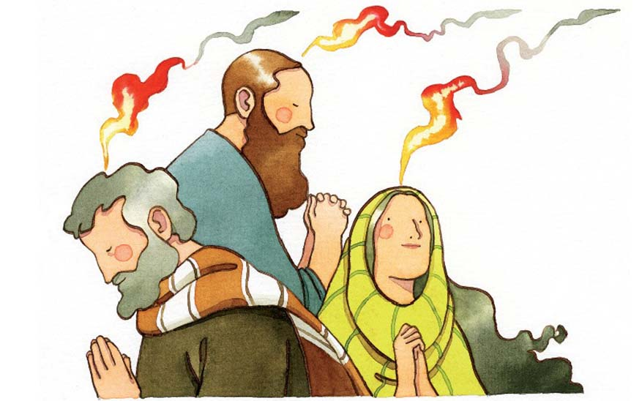
Confirmation is as simple as the Holy Spirit, who is God, increasing our faith so that we have the certainty that He’s with us until we arrive in Heaven, for which He also gives us hope. During this Sacrament, the Holy Spirit strengthens our ability to love Him and others more deeply. The Holy Spirit gives us seven gifts to help us do that
In this case, it has to be a bishop who imposes his hands over the confirmandi and anoints him or her with oil (the Holy Chrism), while he says “I sign thee with the Sign of the Cross, and I confirm thee with the Chrism of salvation, in the name of the Father and of the Son and of the Holy Spirit”.
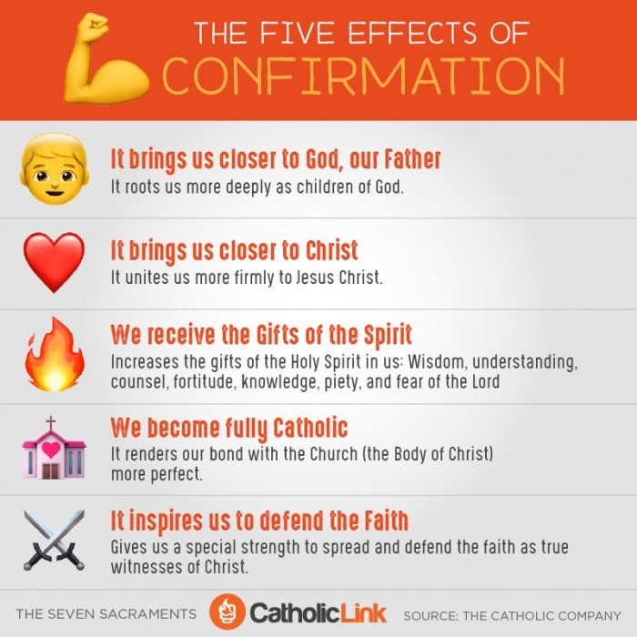

3. The Eucharist
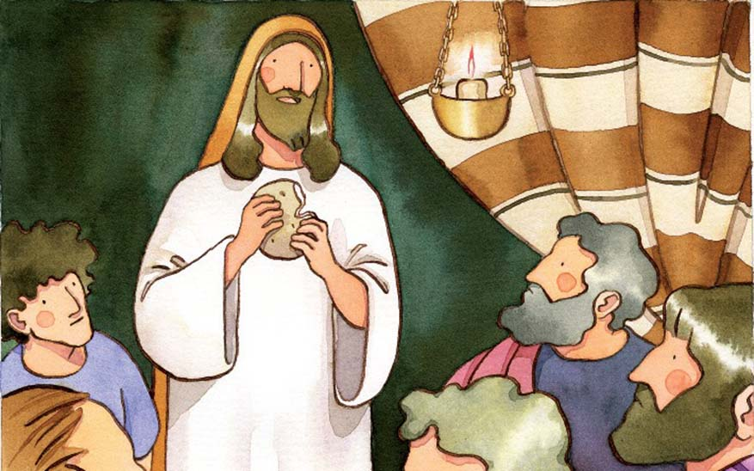
Every day, Jesus turns bread and wine into His Body and Blood during the Holy Mass. This happens at the moment called the Consecration. This way we can eat and receive Him in our soul.
Jesus instituted this Sacrament during the Last Supper with the twelve apostles. This sacrament has a bonus: it forgives venial sins and fortifies us against committing mortal ones in the future. It’s Jesus Himself who is within us.
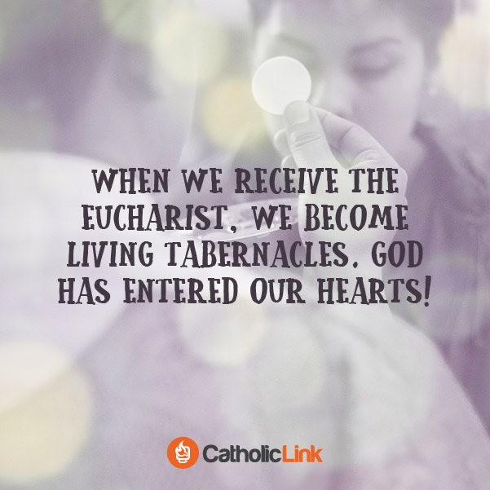

4. Reconciliation
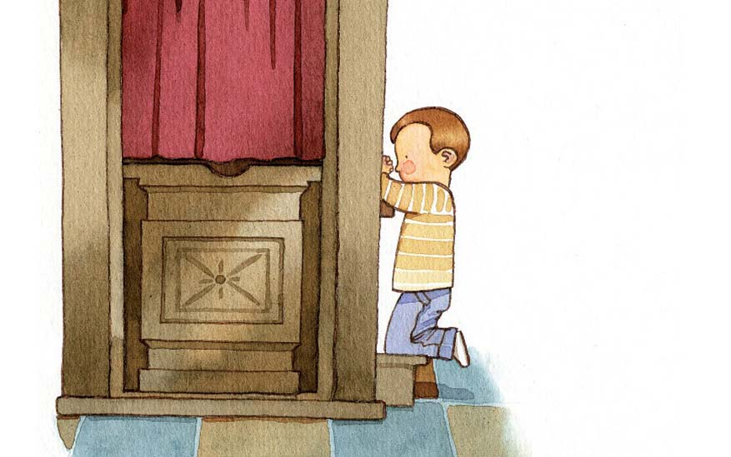
This Sacrament is a great gift from God! God forgives every action and sin of ours that has offended Him when we go to Confession and ask for His mercy and forgiveness.
We must be truly sorry for the bad we’ve done and the good we’ve left undone. The Sacrament of Confession gives us a tremendous peace and increases our strength to be good Christians, good sons and daughters of God.
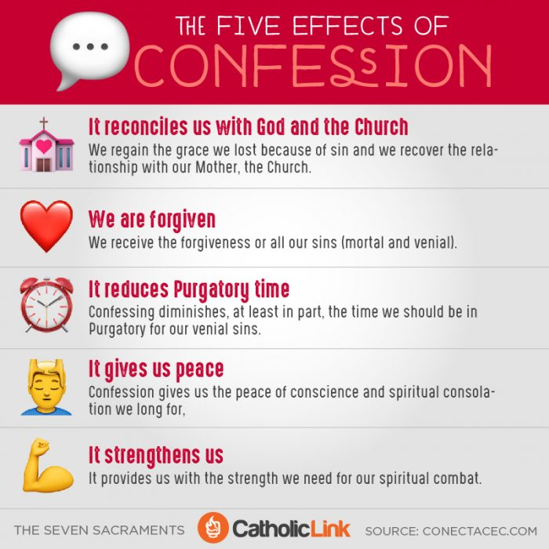

5. Anointing of the Sick
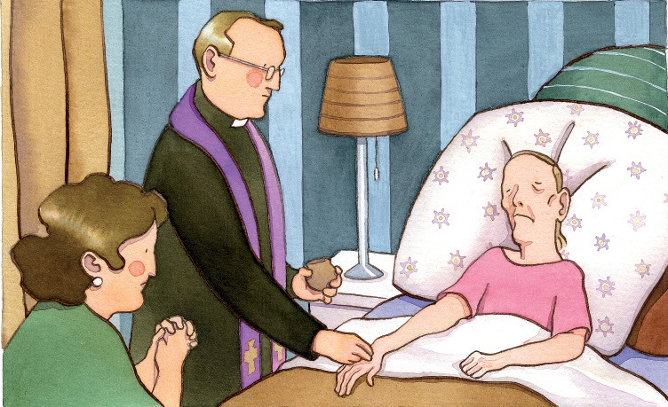
God loves the sick. When someone is very sick or very old and could die soon, they need God’s help for that moment. Anointing by a priest helps bring strength, peace and encouragement. Part of this sacrament is forgiving all the sins of the sick person and preparing him or her for their time of death
The sick, with their pain and suffering, help Jesus to carry the Cross, and at the same time, He helps them during the last moments of their lives.

. 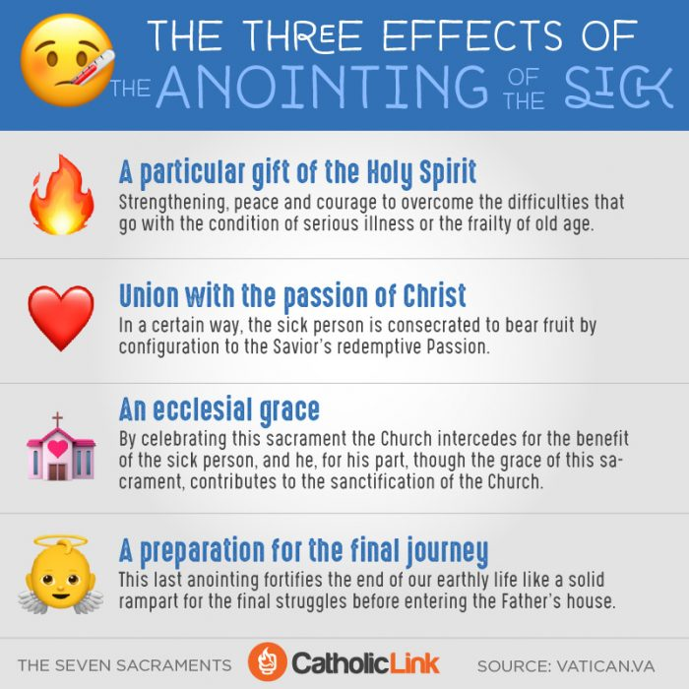
6. Holy Orders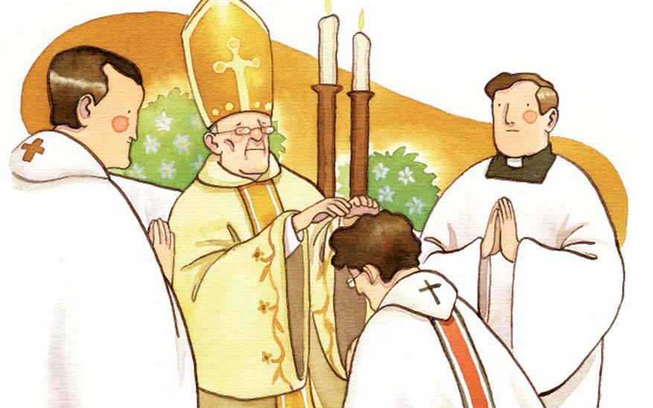
Holy Orders are only received by those called to be priests. This sacrament allows them to become the very men who can administer all of these sacraments to others. It’s a bishop who puts his hands over and prays over the new deacon or priest, consecrating him to Our Lord.
Holy Orders give a special effusion of the Holy Spirit and has a special characteristic: he who receives this sacrament will be a priest forever, his soul permanently marked and called apart by God.
Permanent deacons and Bishops also “receive Holy Orders,” distinct in rites and duties from those of the priest, although a consecrated bishop will himself already be an ordained priest, and most priests spend a year as a transitional deacon prior to their priestly ordinations.
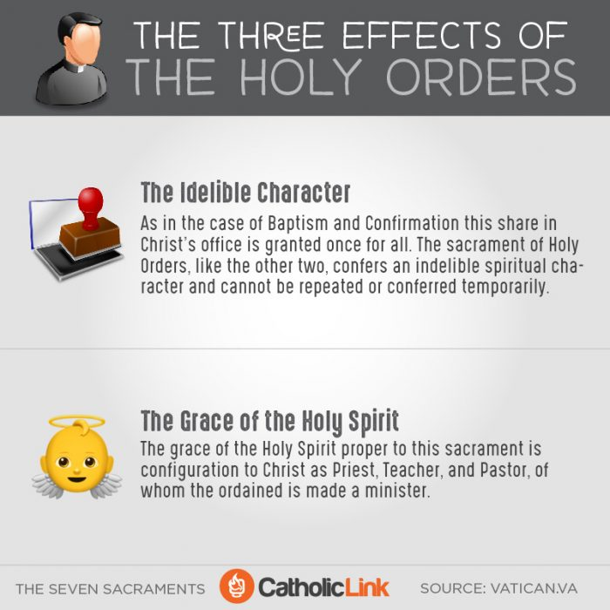

7. Matrimony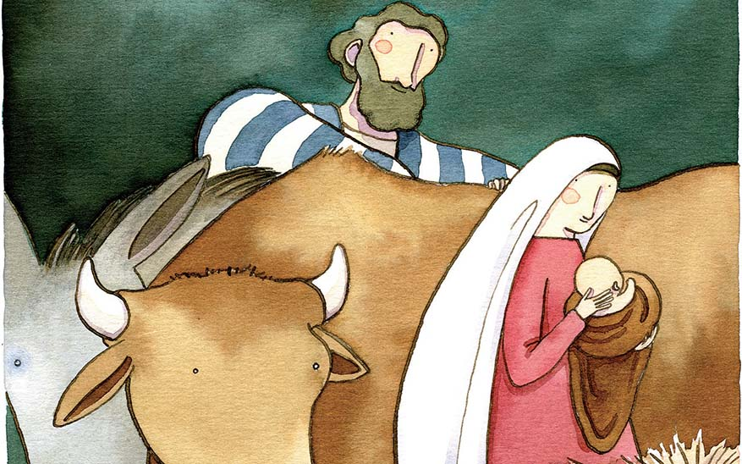
This sacrament is the union between a man and a woman forever. When they marry within the Church, it is God who unites their bodies and souls. Those who get married shall not break their marriage bond: “What God has joined together let no one separate” (Mark 10:9).
The model that men and women have to follow is that of the Holy Family: Jesus, the Virgin Mary and Saint Joseph, as well as being a mirror of Christ’s nuptial bond to His bride, the Church.

