March 7-8, 2026 |  |  |  |  | March 14-15, 2026
Mass |  |  |  |  | Mass | Lectors | Eucharist
4:00 PM | Sarah Hemond | Dave Bettencourt | Pat Lannan |  | 4:00 PM | Anita Marshall | Pat Lannan | Dave Bettencourt
 | Denise Silva | John Lanctot, Jr. | John Lanctot, Sr. |  |  | John Lanctot, Sr. | Ellen Bennet | Ken Espanola
 | Wendy Thibault |  |  |  |  | N/P Squatrito
8:30 AM | Dan Knight | Sue Ann Gale | Catherine Holmes |  | 8:30 AM | Stacey Peterson | Bruce Dyer | OPEN
 | Bill Holmes | Margaret Marston | A/S Peterson |  |  | Margaret Marston | Andy Peterson | Tony Teixeira
 | Diane Davis |  |  |  |  | Elaine Arruda, OFS
11:30 AM | Suzanne Fournier | Milt Finch | Jim Mullen |  | 11:30 AM | Nicholas Tarranova | Ken Bryant | Donna Glavin
 | Ann Teixeira | Carrie A. Marshall | Sally Battison |  |  | John Hadalski | Carrie A. Marshall | Manny Marshall
*Eucharistic Ministers Location:
Folks listed in top two spots plan on going to the middle; those listed in bottom two spots plan on going towards the front entrance door.

March 21-22, 2026 |  |  |  |  | March 28-29, 2026 Palm Sunday
Mass | Lectors | Eucharist |  |  | Mass | Lectors | Eucharist
4:00 PM | Wendy Thibault | Dave Bettencourt | Anita Marshall |  | 4:00 PM | N/P Squatrito | Pat Lannan | John Lanctot, Jr.
 | John Lanctot, Jr. | Ellen Bennet | Ken Espanola |  |  | Anita Marshall | Denise Silva | Wendy Thibault
 | Denise Silva |  |  |  |  | John Lanctot, Sr.
8:30 AM | Sarah Hemond | Bruce Dyer | Sue Ann Gale |  | 8:30 AM | Bill Holmes | Diane Davis | Catherine Holmes
 | Elaine Arruda, OFS | Andy Peterson | Stacey Peterson |  |  | Dan Knight | Sarah Hemond | Tony Teixeira
 | Diane Davis |  |  |  |  | Edna Greene
11:30 AM | Rachel Mundell | Milt Finch | Jim Mullen |  | 11:30 AM | Ann Teixeira | Ken Bryant | John Hadalski
 | Sally Battison | Carrie A. Marshall | OPEN |  |  | Suzanne Fournier | Donna Glavin | Manny Marshall

April 4-5, 2026 |  |  | April 11-12, 2026
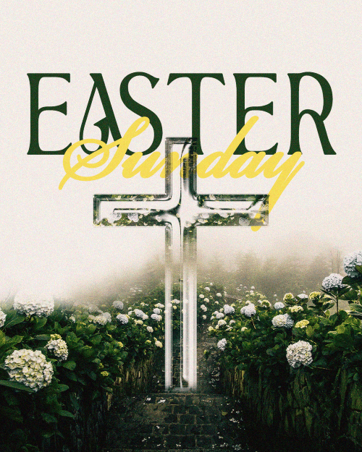 | Sign-up sheets  will be in the Sacristy |  | Mass | Lectors | Eucharist
 | Sign-up sheets  will be in the Sacristy |  | 4:00 PM | Wendy Thibault | Pat Lannan | Anita Marshall
 | Sign-up sheets  will be in the Sacristy |  |  | N/P Squatrito | Ellen Bennet | John Lanctot, Sr.
 | Sign-up sheets  will be in the Sacristy |  |  | John Lanctot, Jr.
 | Sign-up sheets  will be in the Sacristy |  | 8:30 AM | Stacey Peterson | Bruce Dyer | Sue Ann Gale
 | Sign-up sheets  will be in the Sacristy |  |  | Margaret Marston | Andy Peterson | Tony Teixeira
 | Sign-up sheets  will be in the Sacristy |  |  | Elaine Arruda, OFS
 | Sign-up sheets  will be in the Sacristy |  | 11:30 AM | John Hadalski | Milt Finch | Jim Mullen
 | Sign-up sheets  will be in the Sacristy |  |  | Nicholas Tarranova | Carrie A. Marshall | Sally Battison

*Eucharistic Ministers Location:
Folks listed in top two spots plan on going to the middle; those listed in bottom two spots plan on going towards the front entrance door.

