TULIP
Tenant Users Liability Insurance Policy

Corporation of the Catholic Archbishop of Seattle Tenant users may obtain a quote from OneBeacon Entertainment without obligation to buy by doing the following:
- Visit the TULIP website at www.onebeaconentertainment.com
- Under TULIP – Event Insurance click on Purchase or Quote
- Search for your Venue: (Enter Corporation of the Catholic and click Search. A drop down menu will appear below with all venue names / please click the appropriate name and click Next)
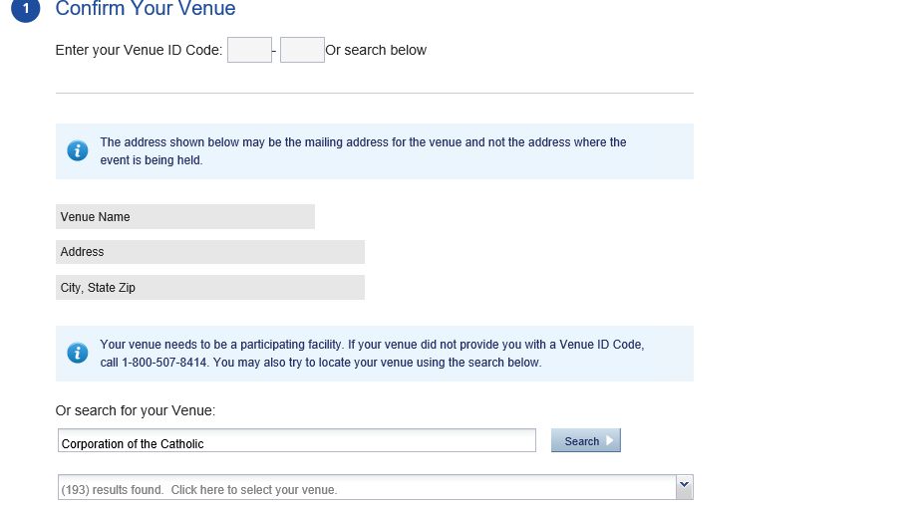
- Complete the steps in the EVENT DETAILS section to obtain a quote
- If you are ready to purchase just complete the form and pay with a credit card
- Should you require further assistance please call the OneBeacon Entertainment TULIP help desk at 800-507-8414 Monday through Friday between 8:30 A.M. and 5:00 P.M. Pacific Time

