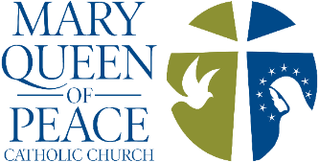
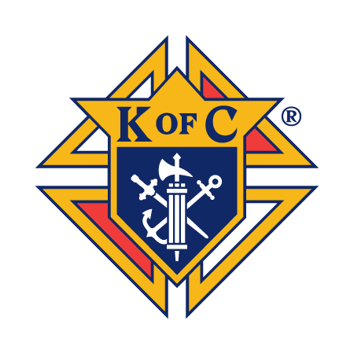
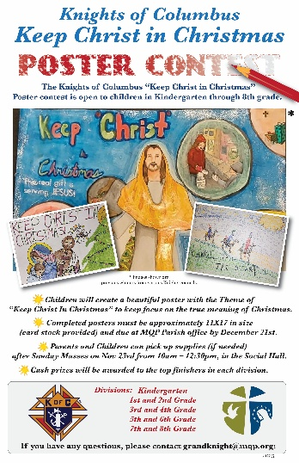
Keep Christ In Christmas (KCIC) Poster Contest
- Contest is open to children in Kindergarten through 8th grade
- Create a 11x17" poster (card stock provided) celebrating the true meaning of Christmas
- Submit Posters to MQP Parish Office by Sunday, December 21st
- Affix this sheet behind the poster when submitting
- Cash prizes will be awarded!
**************************************************************************************************
Entry Form: Submission Instructions
- Child Name =
- Age & Grade =
- Adult Name & Contact # =
Tell us about your poster and how it ‘Keeps Christ In Christmas’ below:

Supplies may be picked up (if needed) in the Marian Social Hall during the following times:
- Saturday, November 22nd from 3pm to 4:45pm - during MQP Advent Wreath Making Event
- Sunday, November 23rd from 10am – 12:30pm - during Coffee & Donuts after both Masses

Thank You!
Knights of Columbus # 9833 Council; Contact David Cinderella GrandKnight@mqp.org

