MASS QUESTION:
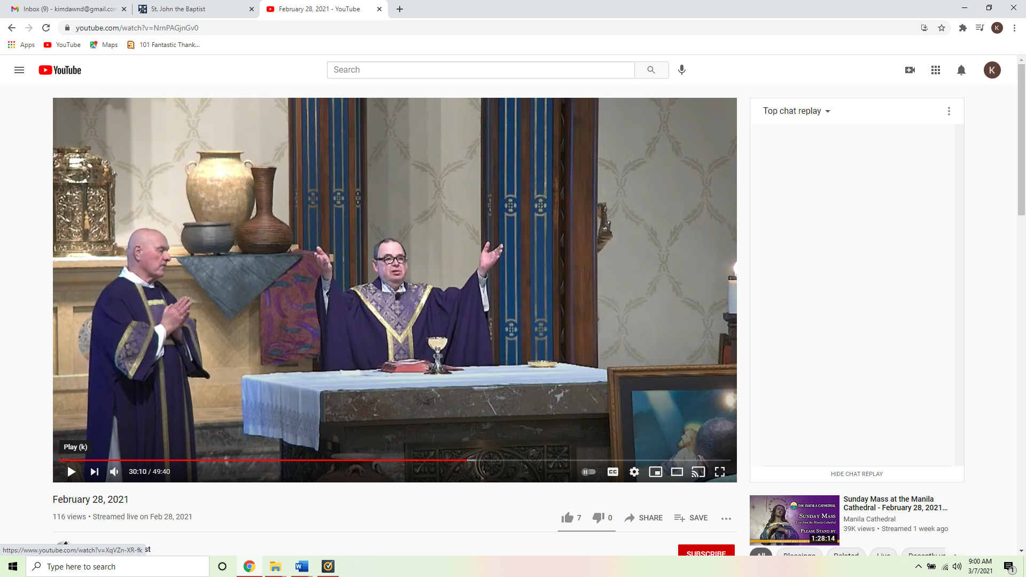
Our church is decorated for the season of Lent. Please tell me what story Jesus told using these water jugs.

Hint: a miracle happened.

