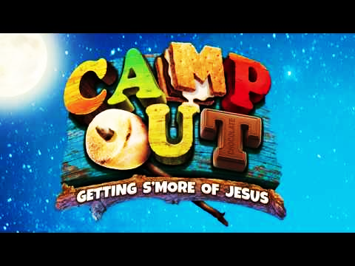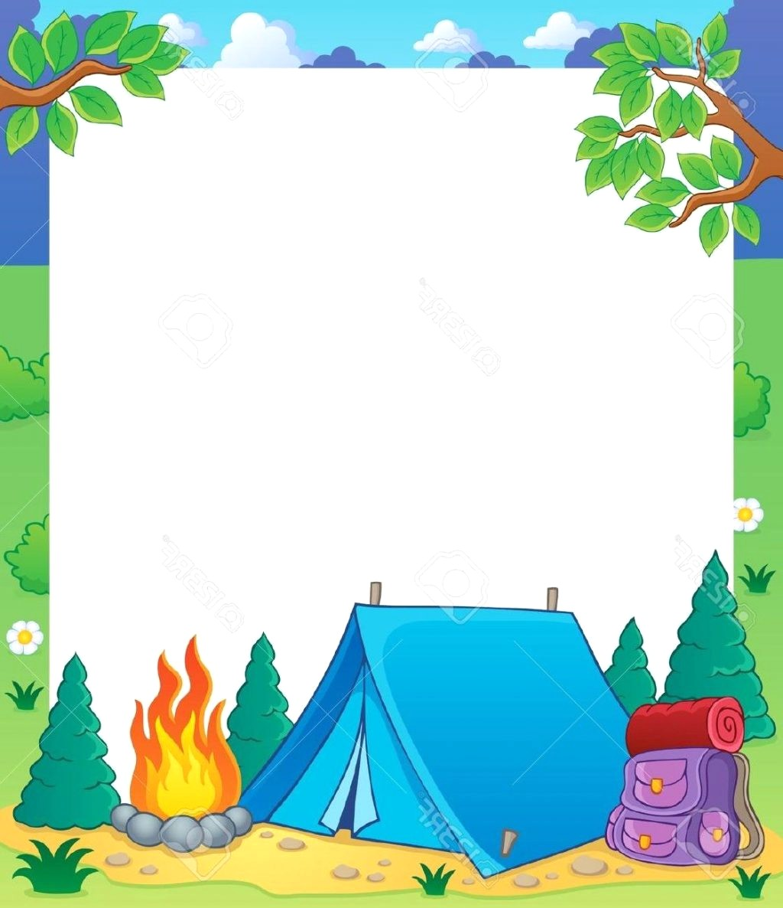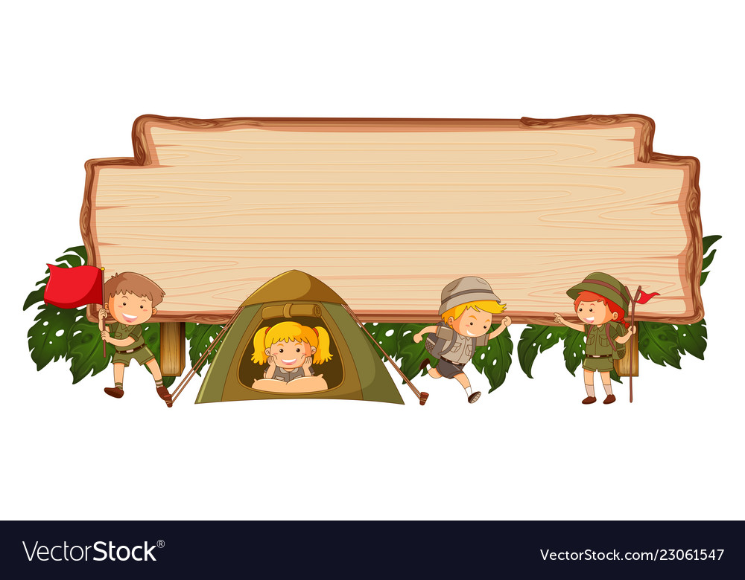

**VBS 2021**

**Friday, July 30**: 6-8:30pm-Snacks provided

**Saturday, July 31**: 9-3pm-Lunch and Snacks provided

**Sunday, August 1**: 9-1pm-Lunch and Snacks provided

Event will be held at St. John the Baptist School in

The Basement of the school, Door A

* **Open to youth in Pre-k through 6th grade.**
* **Doors open 15 minutes prior to start of day.**
* **Participants will be attending mass on Sunday.**

To sign up visit ***www.stjohnbap.org*** and then click on the

Vacation Bible School tab for more information and to sign your child up.

**There is not a fee for this event, donations will be accepted and given to the**

**Whiting Animal Shelter to help the animals who are forced to camp**

**outside all the time but are now safely inside!**

LET’S GO CAMPING

IN GOD’S CREATION