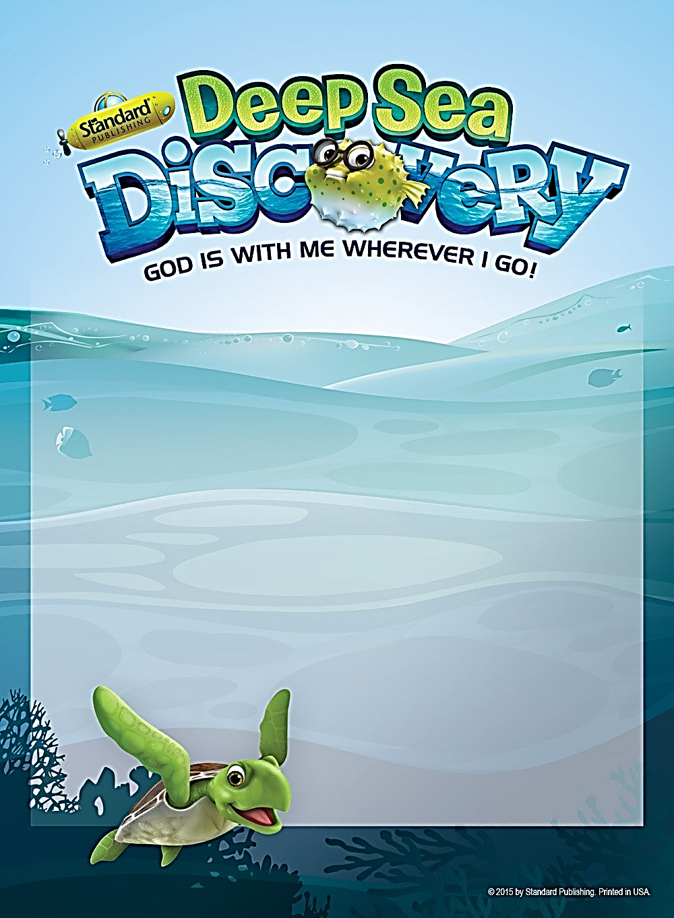

**Sepending time with**

**GOD**

**is how we GROW**

Using

Our GIFTS

Is how we SERVE

**Spending time with OTHERS is how we CARE**

**Sharing our STORY is how we LOVE**

**TUESDAY, JUNE 14**: 10-2pm- Lunch and Snacks provided

**WEDNESDAY, JUNE** **15**: 10-2pm-Lunch and Snacks provided

**THURSDAY, JUNE** **16**: 10-2pm-Lunch and Snacks provided

**FRIDAY, JUNE 17**: 10-2pm-Lunch and Snacks provided

Event will be held at St. John the Baptist School ~ Door A

* **Open to youth in Pre-k through 6th grade.**
* **Doors open 15 minutes prior to start of day.**

To sign up visit ***www.stjohnbap.org*** and then click on the

Vacation Bible School tab for more information and to sign your child up.

**There is not a fee for this event, donations will be accepted and**

**given toward our service project to benefit the Whiting Animal Shelter.**

**VBS 2022**