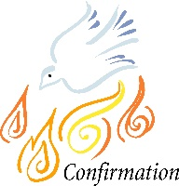
Holy Spirit Parish Confirmation Class of 2020

Discipleship Formation Sessions
6:30-8:30pm in the Parish Hall
Dinner will be provided.

Session 1 – Sunday, February 9th
Session 2 – Sunday, March 8th
Session 3 – Sunday, April 5^{h}
Session 4 – Sunday, May 3rd
Session 5 – Sunday, June 7th
Session 6 – Sunday, July 12th
Session 7 – Sunday, August 2nd
Session 8 – Sunday, September 13th
Session 9 – Sunday, October 4th
Retreat– Saturday, November 7th 9am-2pm
Date of Confirmation TBA

Confirmation Sessions are for all current 10th graders in the 2019-2020 school year.
The Sessions begin in the 2nd Semester of school, see the calendar above.
If you have an 11th or 12th grader who has yet to be Confirmed, please contact us.
Registration forms can be found in the office, on our website, or can be sent by email if requested. Adults needing to be Confirmed need to make an appointment with Father to discuss if RCIA is necessary.

Charity Firestone
Parish Catechetical Leader
334-277-1989 (office) 509-389-0399 (cell)
dre@holyspiritmgm.org

