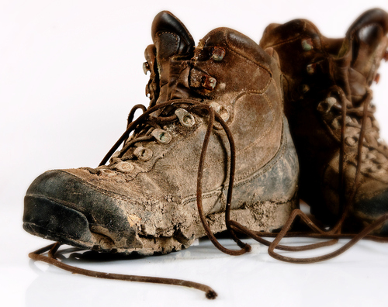
Project Life
2018

WHO: High school students and young adult chaperones

WHAT: Project Life gathers teens from various backgrounds to be transformed by the Gospel call to love one another through service to those in need. Throughout the course of the week, teens (aka "Feet Washers") come to know and recognize Jesus Christ in themselves and in the people they serve. Through spiritual programming, great music, hard work, and good times, Project Life has become an awesome event that allows Christ to speak and work through them in ways they would never have imagined!
WHEN: Sunday, June 10 – Friday, June 15, 2018
WHERE: St. Vincent DePaul Parish and School – Perryville, MO
COST: $225 (includes lodging, programming, t-shirt, meals)

Please call or email Youth Minister Courtney Rockamann with any questions! 314.878.2120 ext18 and youth@stanselmstl.org
Project Life 2018
Participant Name ___________________________________________ Birthday _________________
Home Address ____________________________ City ___________ State _____ Zip ____________
Age ____________ M/F __________ High School ________________ Graduation Year ________
Home Parish _________________________ T-Shirt Size (circle one; adult sizes) S M L XL XXL
Participant Cell ____________________________ Participant Email ___________________________
Parent Names ___________________________ Primary Email Address _________________________
Mom Cell _____________________ Dad Cell ___________________
Medical Information/Health History (please attach a copy of your child’s insurance card)
Allergies _____________________________ Rx and Dosage ________________________________
Physician Name __________________________ Physician’s Phone _____________________
Emergency Contact Information (if parent(s) can’t be reached in event of an emergency)
Name ________________________ Relationship _______________ Phone ______________________
Parental/Guardian and Participant - Liability Waver, Media and Medical Consent Form, and Agreement
As the parent or guardian of _______________________________(‘child’), in signing this form, I hereby state that the information included in this form is correct and give permission for my child to participate in the Project Life service week in Perryville, Missouri from June 10-15, 2018.
1. I understand that my child is under the supervision of his/her youth minister, chaperones, and the Archdiocese of St. Louis staff and volunteers.
2. I recognize that there are risks inherent in participation in any activity and agree to hold the youth minister, chaperones, the Archdiocese of St. Louis, its affiliates and its and their employees, volunteers and agents, harmless from any injury to my child or damage to or loss of personal property of my child not caused by the negligence or misconduct of the youth minister, chaperones, nor Archdiocese of St. Louis, its affiliates and their employees, volunteers and agents.
3. In case of a medical emergency, I understand that every effort will be made to contact me, but in the event that I cannot be reached, I hereby give permission for my child to be evaluated, diagnosed and treated in accordance with standard medical practice by licensed medical personnel.
4. I authorize employees and agents of St. Anselm and the Archdiocese of St. Louis to give my child nonprescription drugs (e.g. Tylenol, Ibuprofen, Benadryl, etc.) in the event that circumstances reasonably demonstrate that my child is in need of them.
5. I give permission and release from all liability the Archdiocese of St. Louis and St. Anselm Parish to use any photographs or video footage taken of my child in print, on their website, on Instagram, Twitter, Facebook, etc. for promotional purposes.
6. I understand that if my youth behaves in a manner that is deemed inappropriate or is continually disruptive or if my youth is found with illegal drugs or alcohol (zero tolerance policy), I will be called to immediately pick up my youth from the retreat sight.

Participant’s Signature ________________________________________ Date ________________
Parent/Guardian Signature _____________________________________ Date _______________

