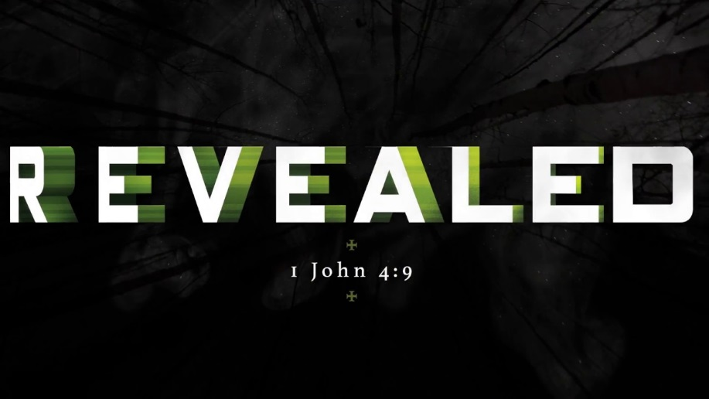
Steubenville Mid-America Conference 2018

WHO: 8th grade students, high school students, college students, parent and young adult chaperones
WHAT: Steubenville STL Mid-America is a high-energy youth conference where thousands of teens are invited to encounter Jesus Christ through dynamic speakers, engaging music, the Sacraments, small group discussions, and fellowship with other teens.
WHEN: Friday, July 13 – Sunday, July 15
WHERE: Missouri State University – Springfield, MO
COST: $250 (includes transportation, lodging, programming, t-shirt, most meals)

Please call or email Youth Minister Courtney Rockamann with any questions! 314.878.2120 ext18 and youth@stanselmstl.org

Elevate – Steubenville Youth Conference 2018
Participant Name ___________________________________________ Birthday _________________
Home Address ____________________________ City ___________ State _____ Zip ____________
Age ____________ M/F __________ High School ________________ Graduation Year ________
Home Parish _________________________ T-Shirt Size (circle one; adult sizes) S M L XL XXL
Participant Cell ____________________________ Participant Email ___________________________
Parent Names ___________________________ Primary Email Address _________________________
Mom Cell _____________________ Dad Cell ___________________
Medical Information/Health History (please attach a copy of your child’s insurance card)
Allergies _____________________________ Rx and Dosage ________________________________
Physician Name __________________________ Physician’s Phone _____________________
Emergency Contact Information (if parent(s) can’t be reached in event of an emergency)
Name ________________________ Relationship _______________ Phone ______________________
Parental/Guardian and Participant - Liability Waver, Media and Medical Consent Form, and Agreement
As the parent or guardian of _______________________________(‘child’), in signing this form, I hereby state that the information included in this form is correct and give permission for my child to participate in the “Steubenville Conference” in Springfield, Missouri from July 13-15, 2018.
1. I understand that my child is under the supervision of his/her youth minister, chaperones, and the Archdiocese of St. Louis staff and volunteers.
2. I recognize that there are risks inherent in participation in any activity and agree to hold the youth minister, chaperones, the Archdiocese of St. Louis, its affiliates and its and their employees, volunteers and agents, harmless from any injury to my child or damage to or loss of personal property of my child not caused by the negligence or misconduct of the youth minister, chaperones, nor Archdiocese of St. Louis, its affiliates and their employees, volunteers and agents.
3. In case of a medical emergency, I understand that every effort will be made to contact me, but in the event that I cannot be reached, I hereby give permission for my child to be evaluated, diagnosed and treated in accordance with standard medical practice by licensed medical personnel.
4. I authorize employees and agents of St. Anselm and the Archdiocese of St. Louis to give my child nonprescription drugs (e.g. Tylenol, Ibuprofen, Benadryl, etc.) in the event that circumstances reasonably demonstrate that my child is in need of them.
5. I give permission and release from all liability the Archdiocese of St. Louis and St. Anselm Parish to use any photographs or video footage taken of my child in print, on their website, on Instagram, Twitter, Facebook, etc. for promotional purposes.
6. I understand that if my youth behaves in a manner that is deemed inappropriate or is continually disruptive or if my youth is found with illegal drugs or alcohol (zero tolerance policy), I will be called to immediately pick up my youth from the retreat sight.

Participant’s Signature ________________________________________ Date ________________
Parent/Guardian Signature _____________________________________ Date ________________

