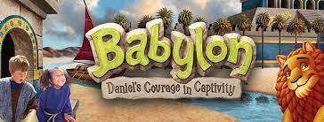

St. Mary by the Lake & St. Matthew
Vacation Bible School Adult VOLUNTEER

NAME:________________________________________________________
PHONE:___________________________________________
CELL: _____________________________________________
EMAIL: ______________________________________________________
Emergency Contact: _________________________________________
Emergency Phone: __________________________________________
Safeguarding God’s Children Training completed: Y N
I acknowledge that I am participating as an Adult Leader for the St. Mary by the Lake & St. Matthew Vacation Bible School Program July 31-August 4, 2023, 8:30am-12:30pm. I also authorize the use of photos for program and parish promotional purposes.

________________________________________ Signature

Please return to Jen Wiseman @ St. Mary by the Lake by July 7, 2023

